1. Create a virtual network with 2 subnets. Each subnet should have 16 Ips only.

Steps:

1. Search Virtual network on Azure.
2. Click on create.
3. Write resource group name by clicking on create new. Fill name. 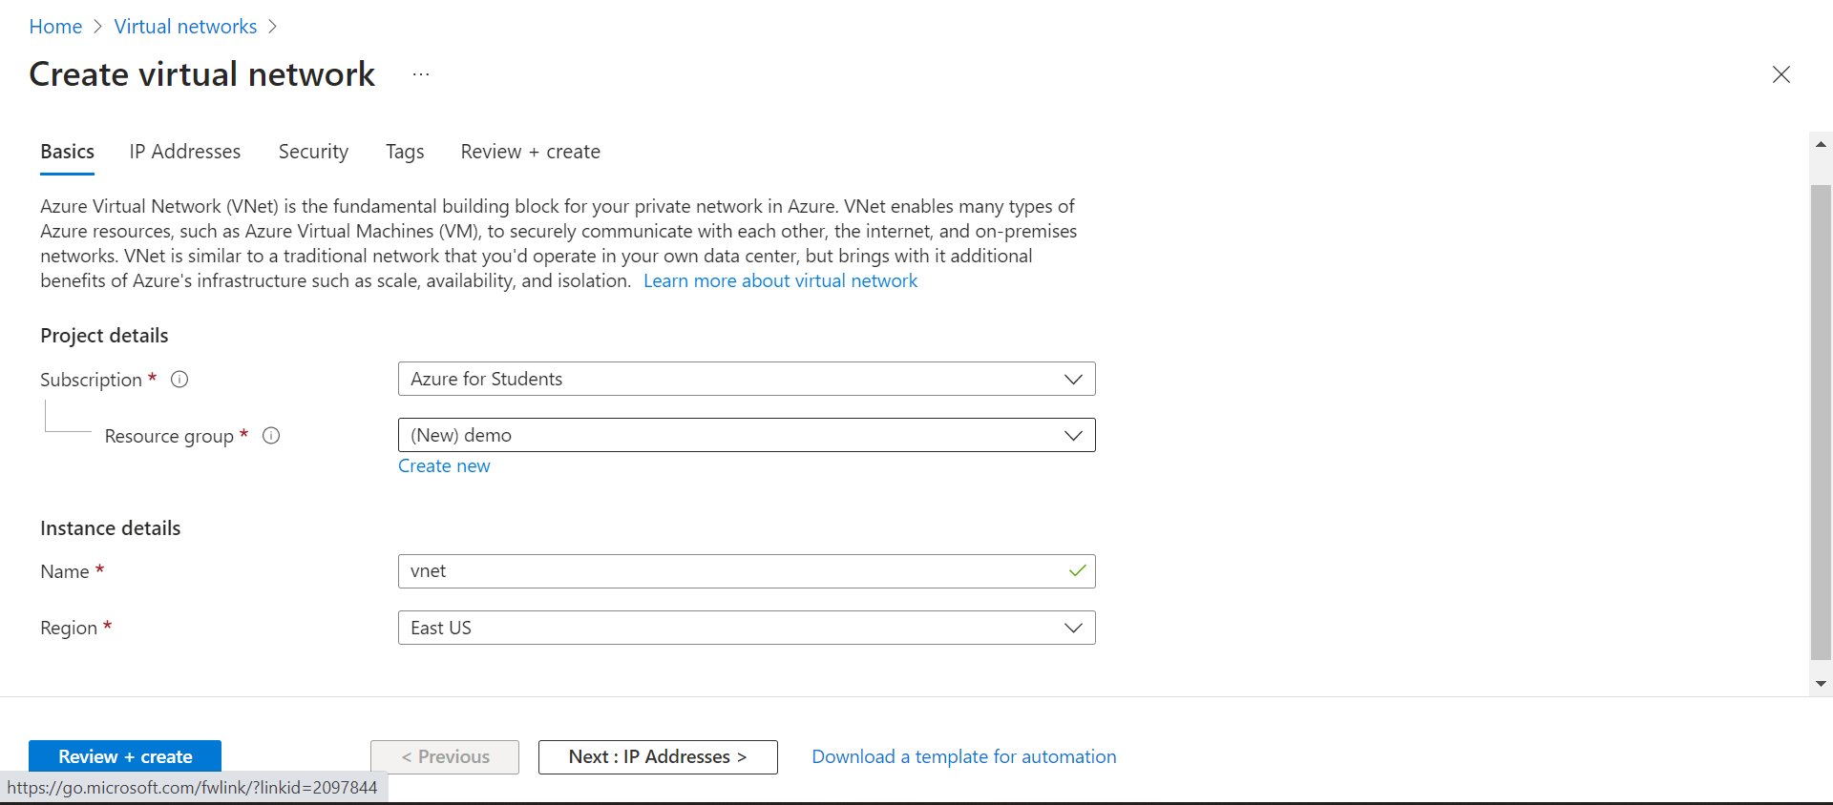
4. Click on next. 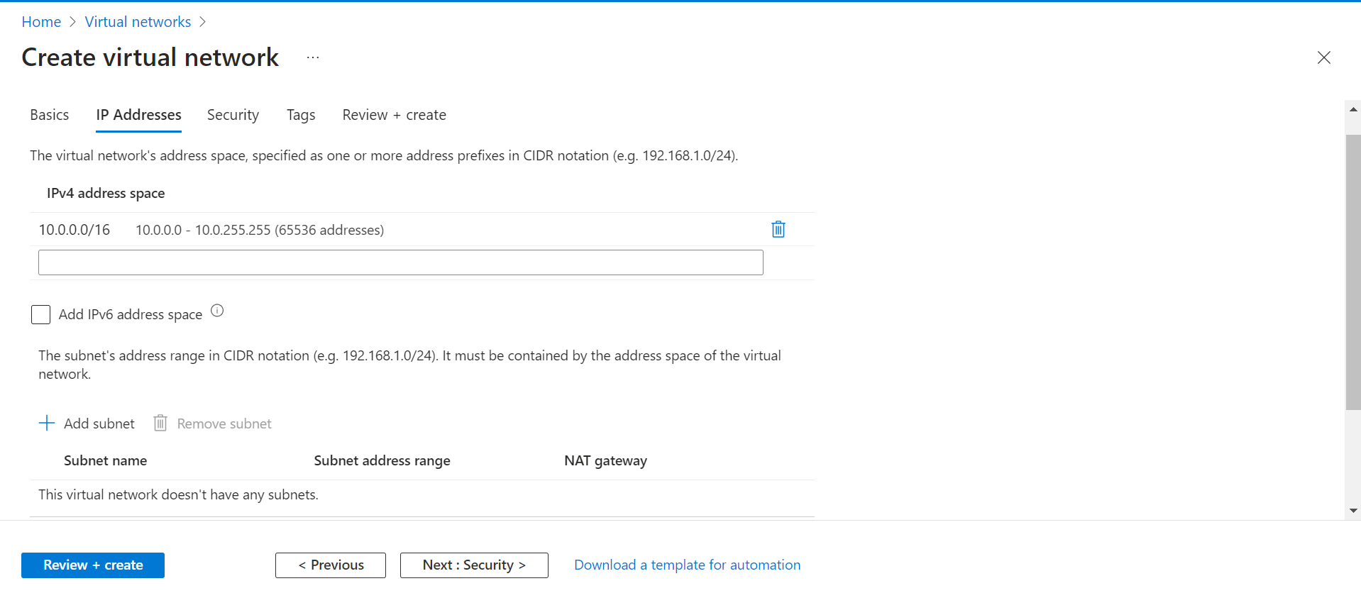
5. click on add subnet. Write subnet name and address as follow to create 16ips.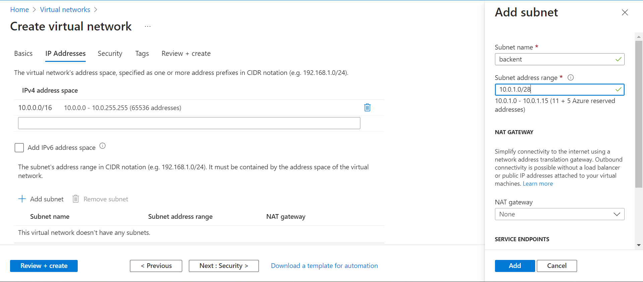
6. Repeat same step to create another subnet as shown. 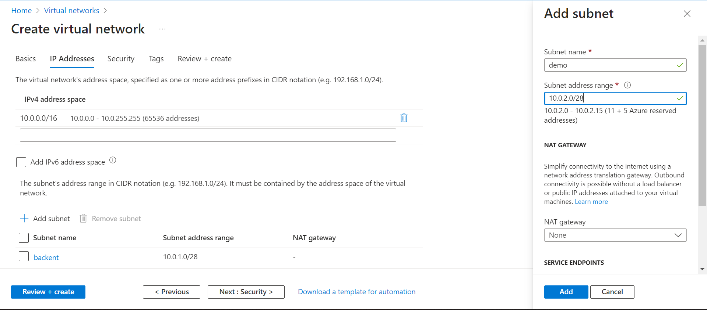
7. Subnet created. 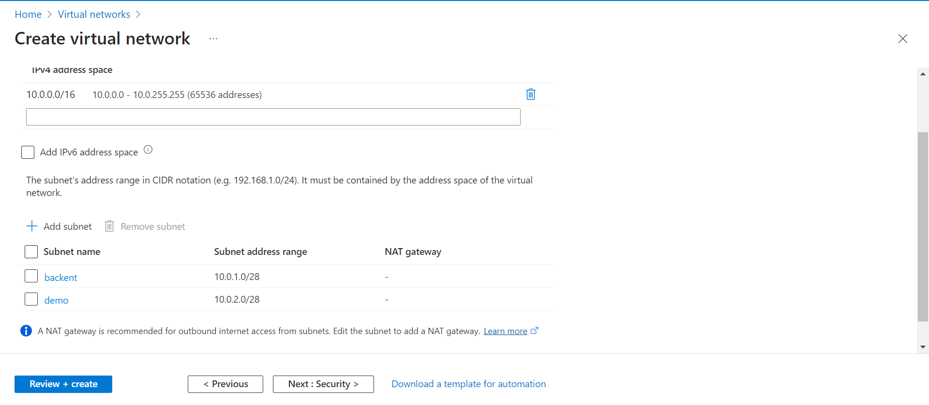
8. Click on next until Review+create. 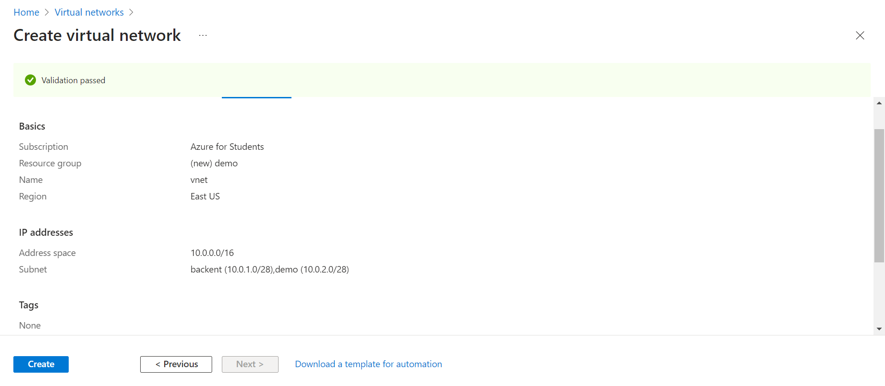
9. Validation passed now click on create. Virtual network created with 2 subnets.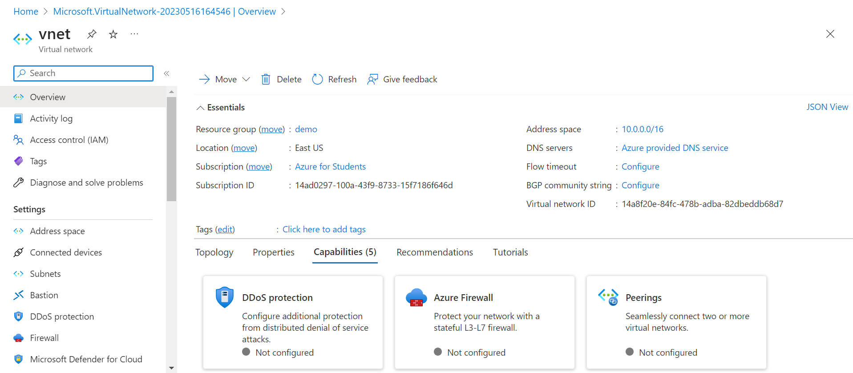
10. Two subnet with 16 Ips. 11 available 5 reserved. 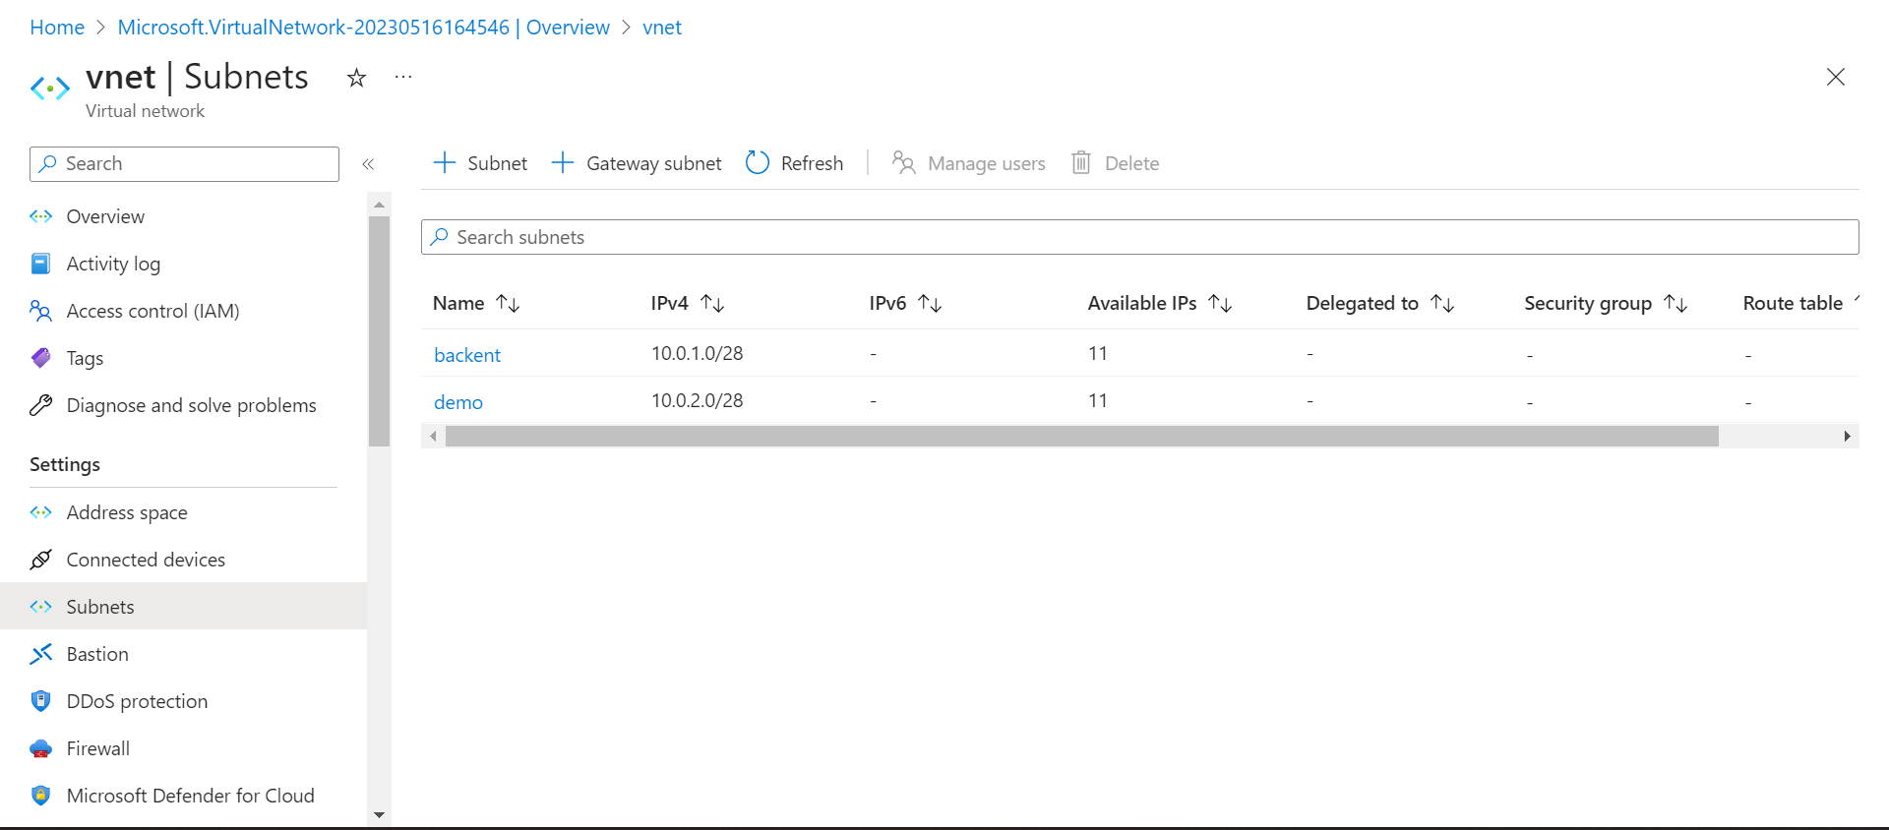

* Inside one of the subnets, create a VM and deploy an application code inside it and it should leverage the database on the cloud (any existing application created by you before)

1. Search Virtual network on Azure click on create then create virtual machine. 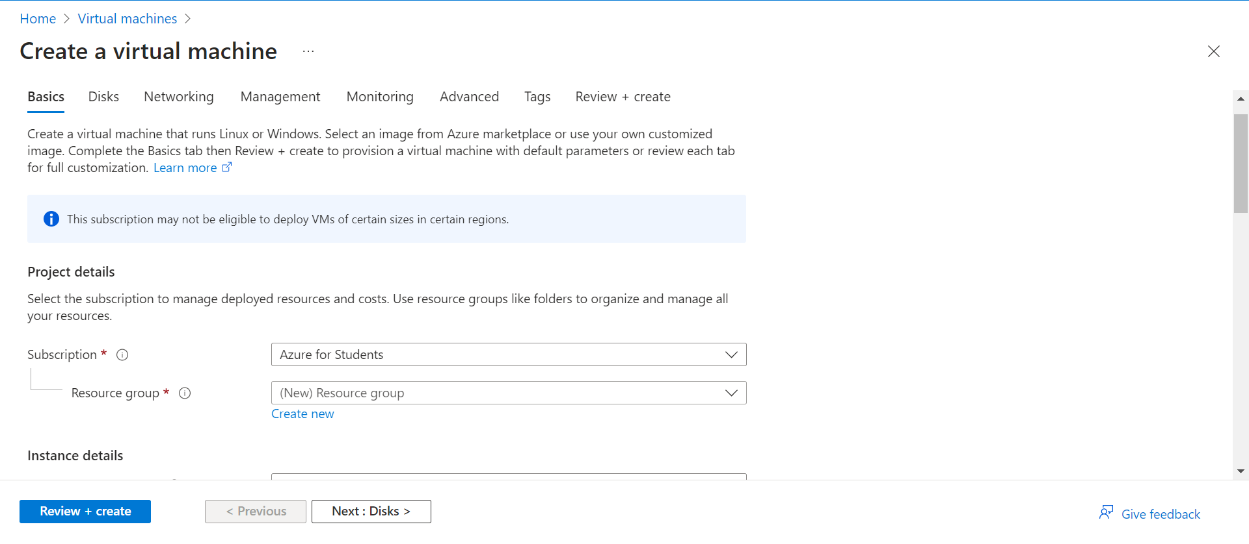
2. Select Virtual group, virtual machine name , region as in screen shot. Put rest as default. 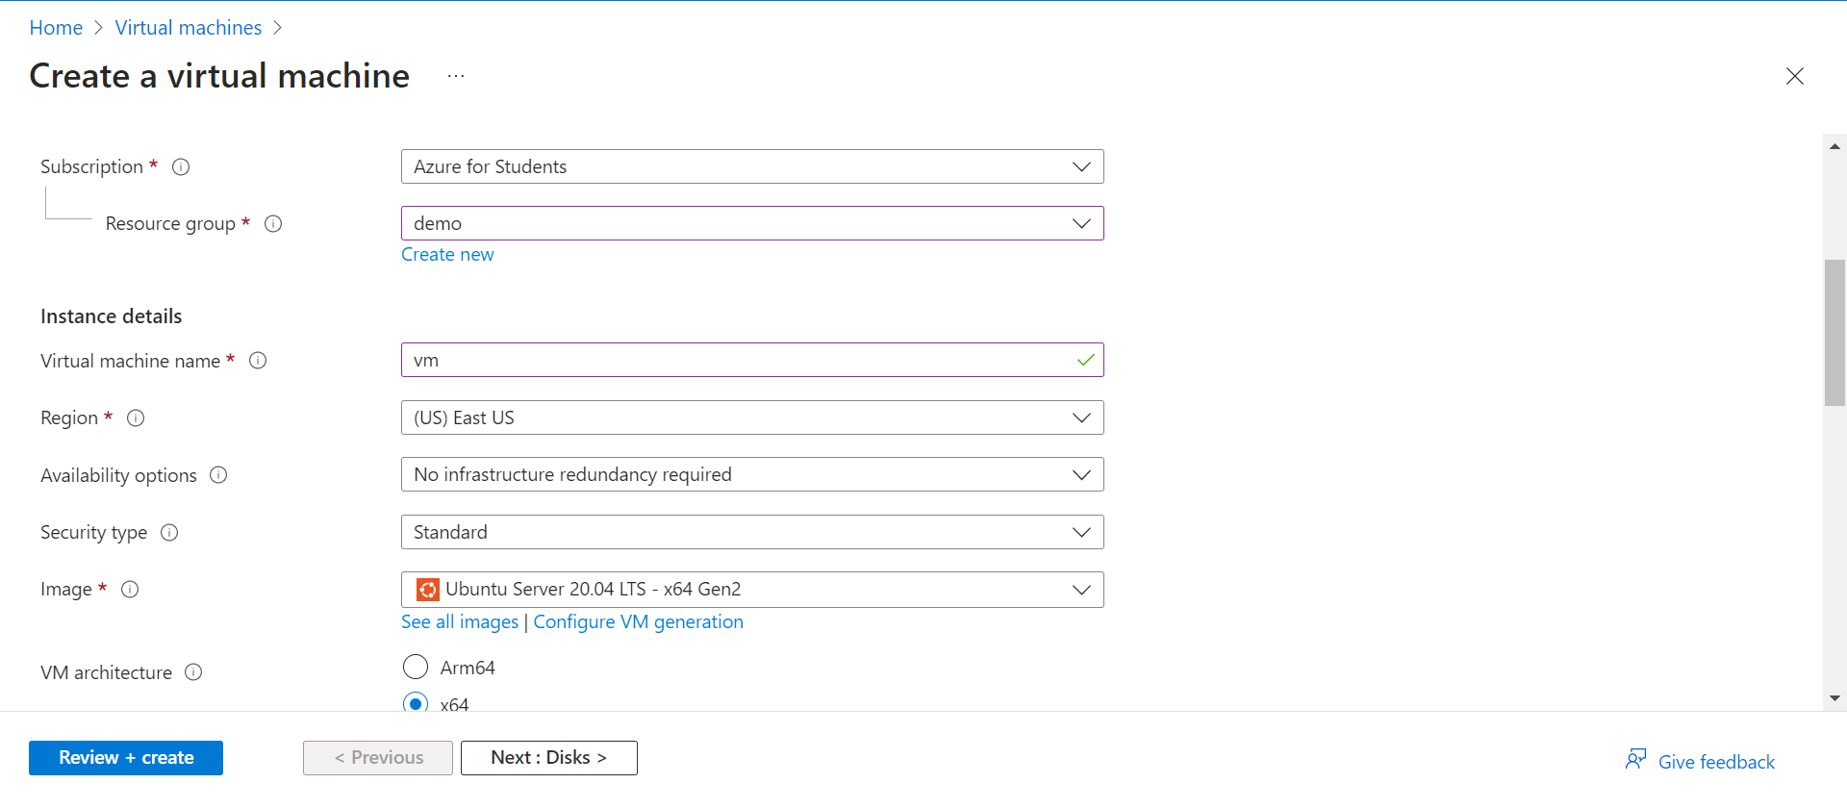
3. Click on next and come to networking. Select virtual network and subnet as show rest as default. 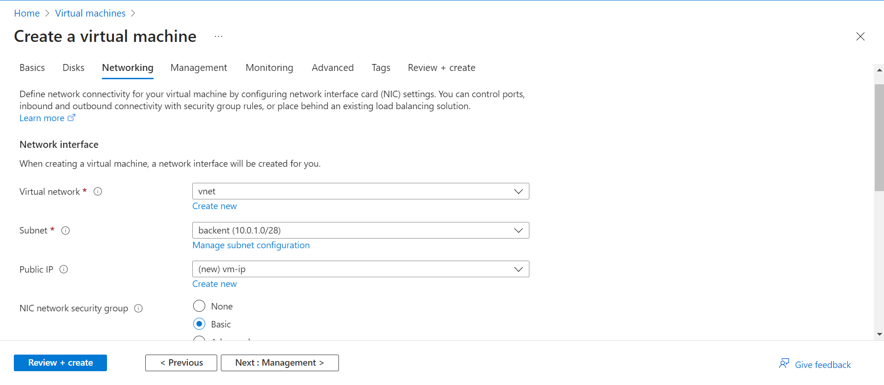
4. Click on next leave everything as default go to review+create. 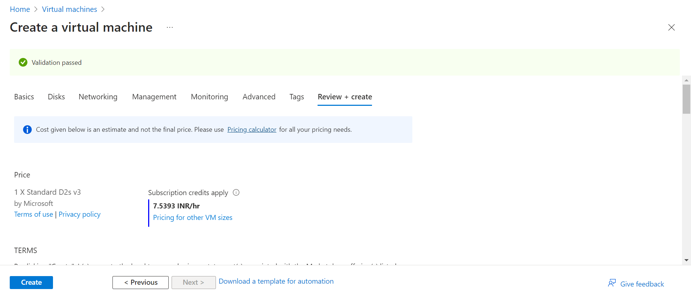
5. Click on create and download the key. 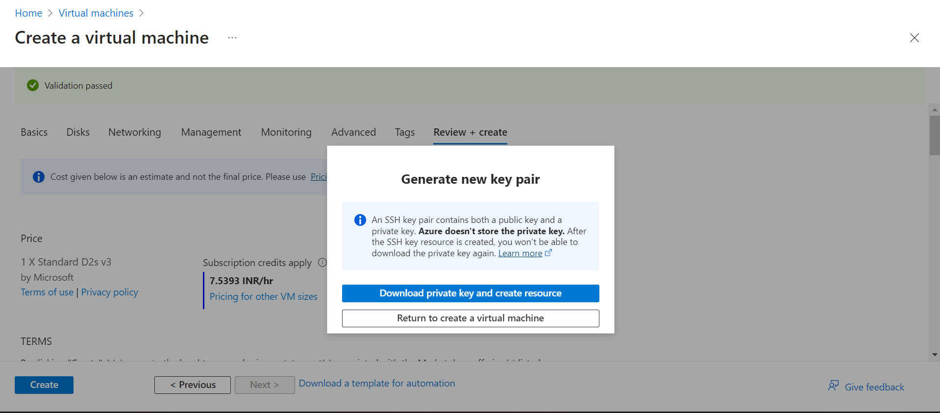
6. VM created. 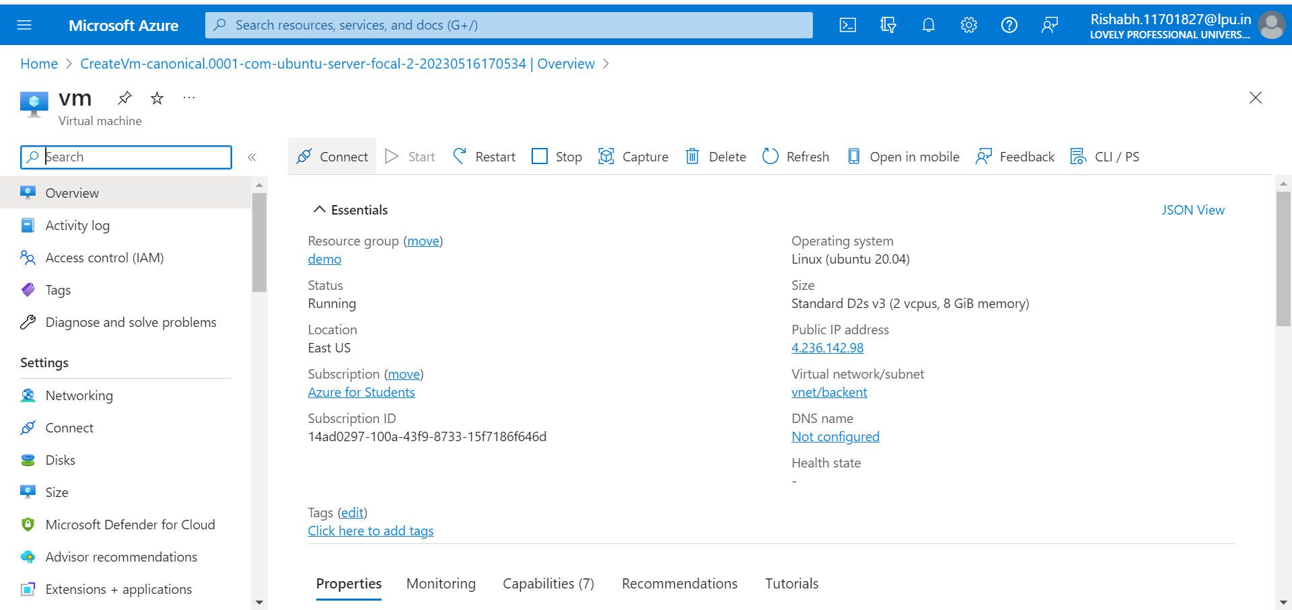
7. Open Cloud Shell. Bash. Upload the key downloaded in step 5. 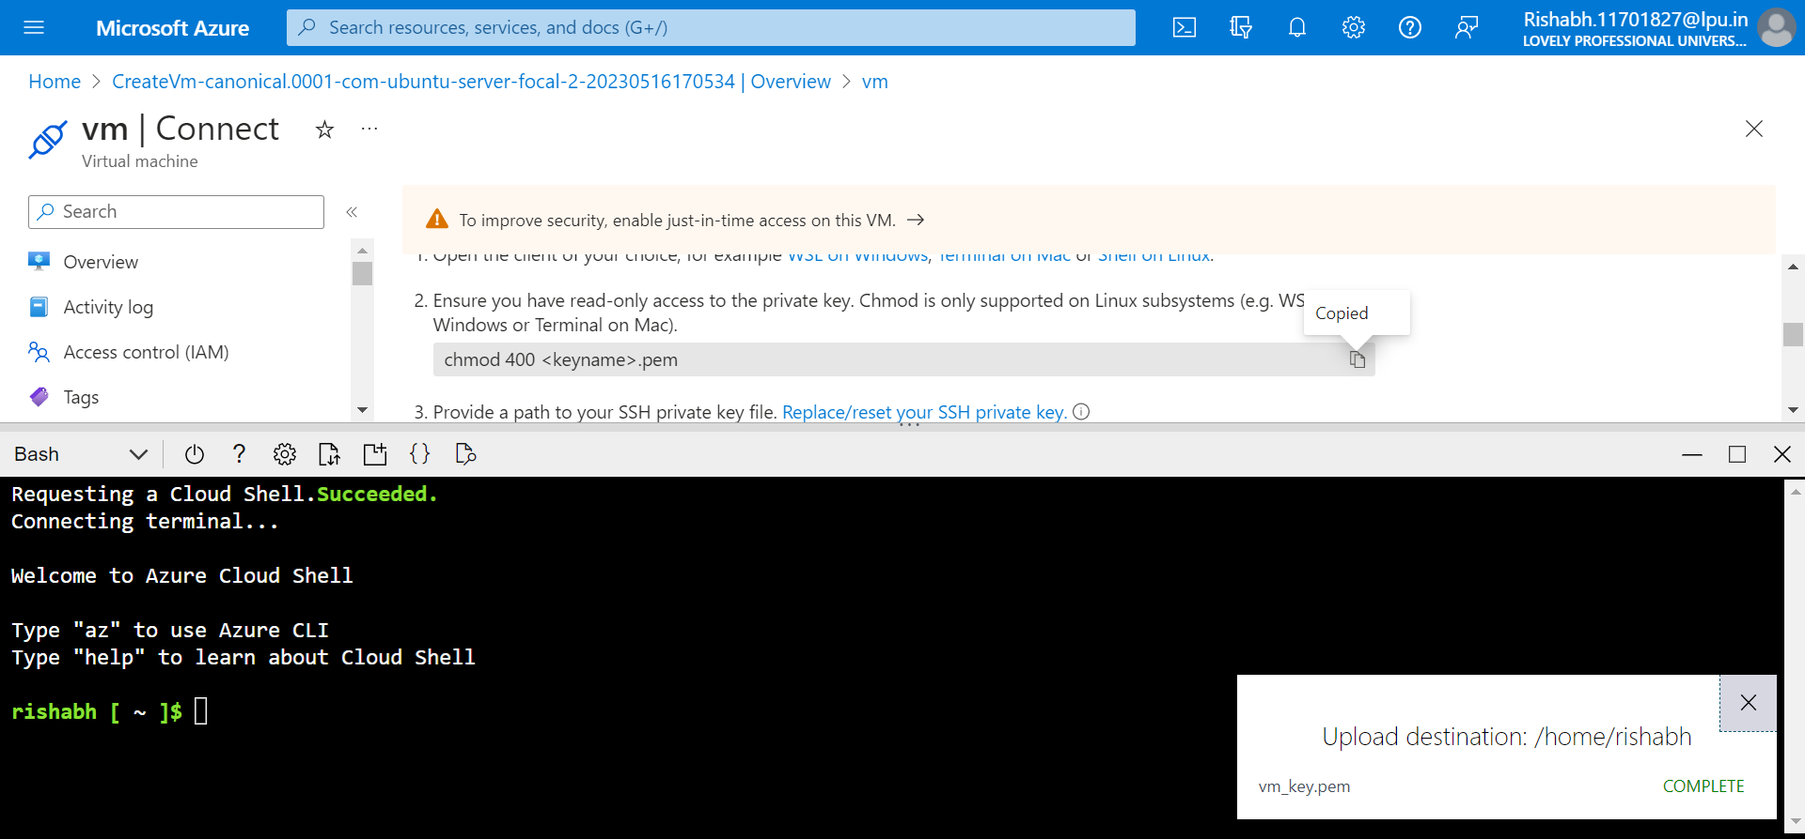
8. Type commands as shown. Then type yes and click enter. Now you will be connect to vm.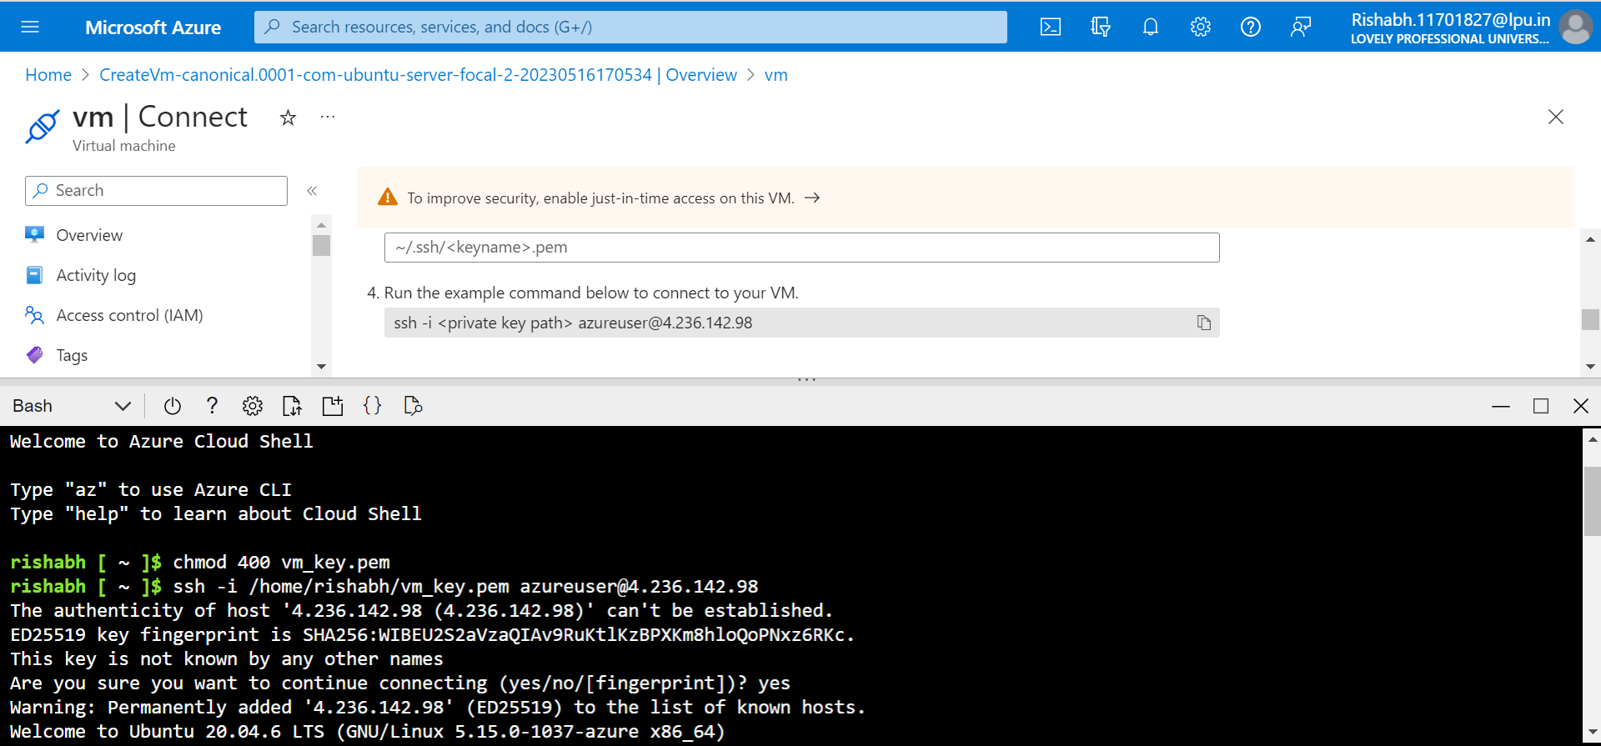
9. Now Download WINSCP to upload your projects in the vm. Copy public ip of your VM paste on host name in WINSCP as show. Write username as shown. 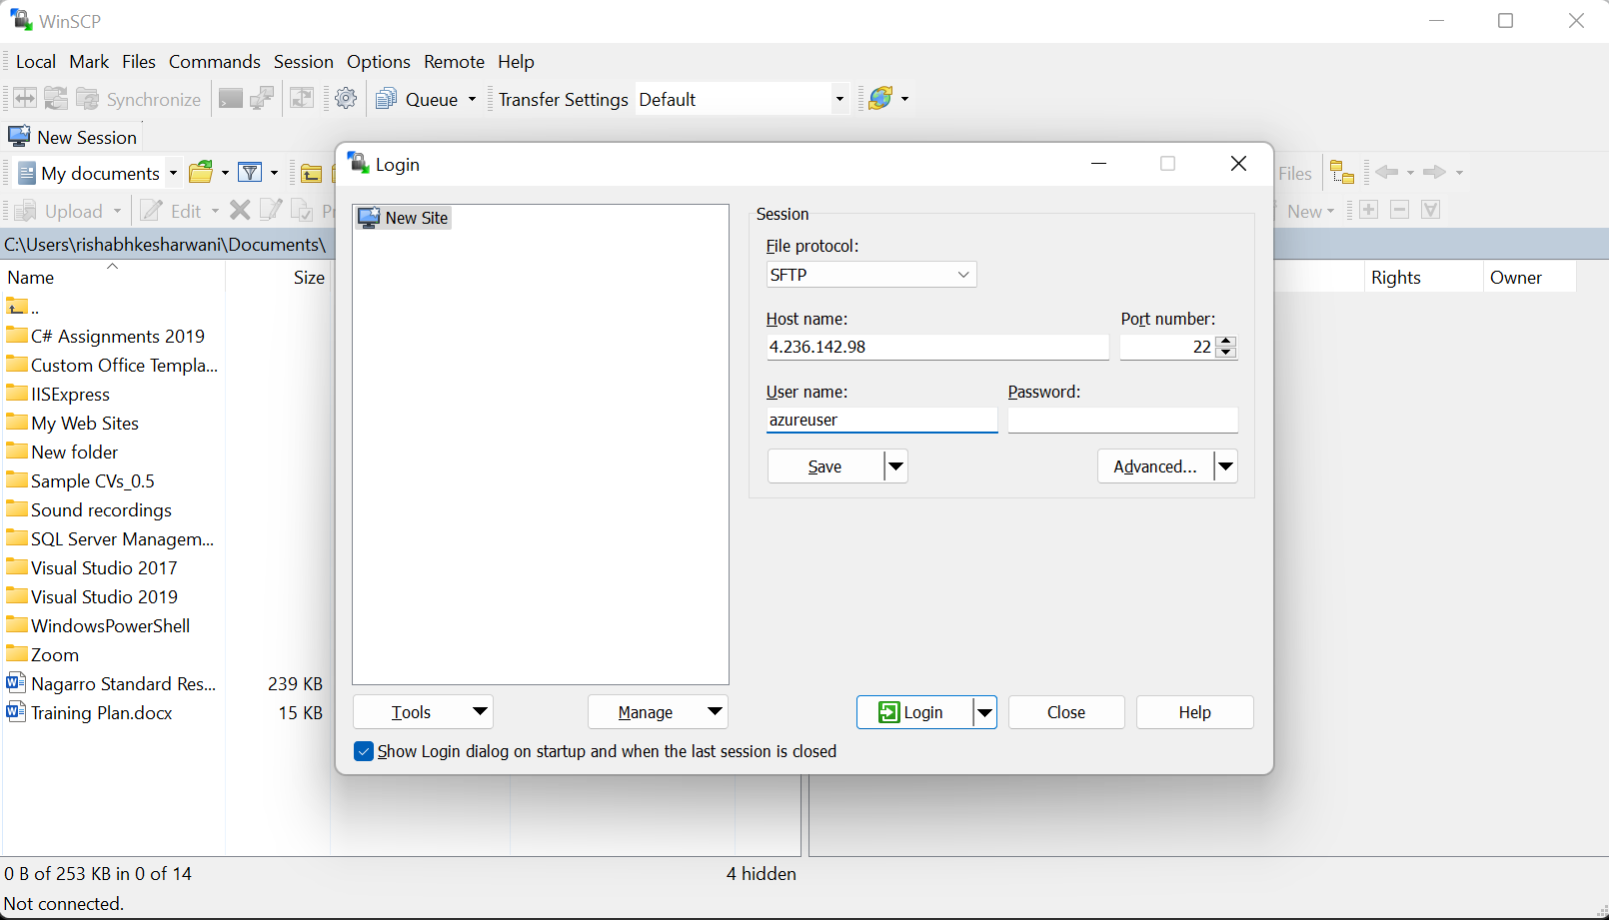
10. Click on advance. Go to authentication choose the ppk file as shown. Then click on ok and login. 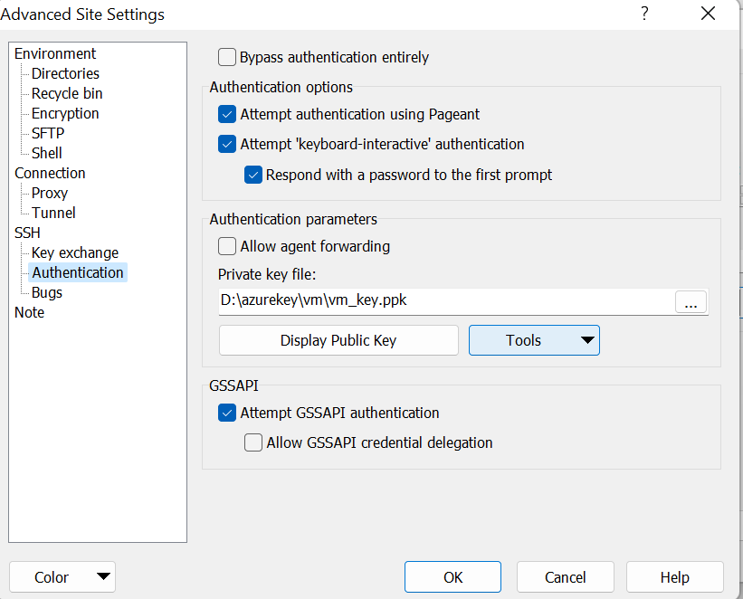
11. Upload project to deploy on VM using WINSCP as shown. 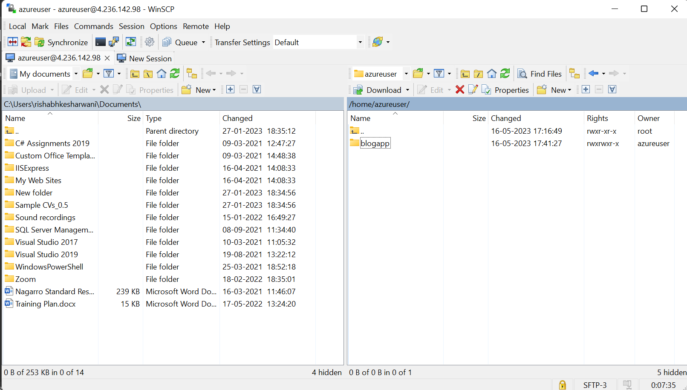 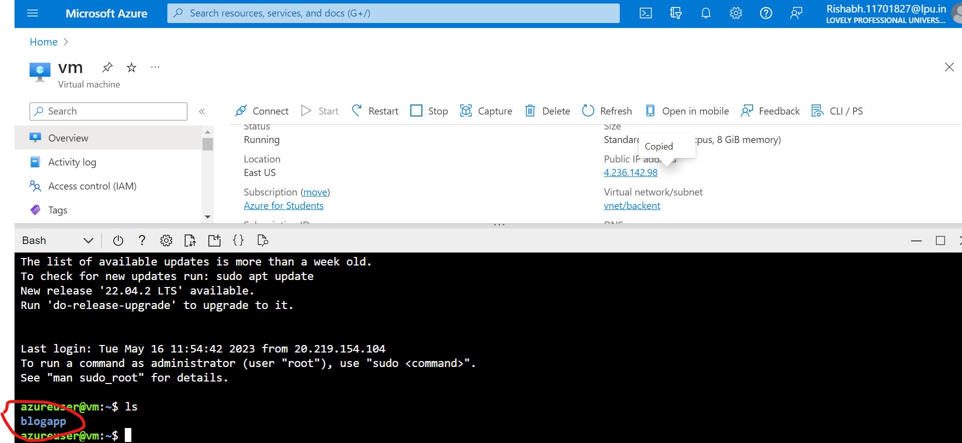
12. Run the following command on bash now.
    1. curl -sL https://deb.nodesource.com/setup_14.x | sudo -E bash –
    2. sudo apt-get install -y nodejs
    3. node --version && npm –version ------to check node and npm version----
    4. wget -qO - https://www.mongodb.org/static/pgp/server-4.4.asc | sudo apt-key add –
    5. echo "deb [ arch=amd64,arm64 ] https://repo.mongodb.org/apt/ubuntu focal/mongodb-org/4.4 multiverse" | sudo tee /etc/apt/sources.list.d/mongodb-org-4.4.list
    6. sudo apt-get update.
    7. npm i.
    8. sudo apt-get install mongodb-org
    9. sudo systemctl start mongod.
    10. sudo systemctl status mongod.
    11. sudo systemctl enable mongod.
    12. sudo npm i pm2 -g.
    13. cd blogapp.
    14. pm2 start app.js.
    15. sudo apt install nginx.
    16. sudo vi /etc/nginx/sites-available/nodeApp.
    17. Now write the configuration as shown below. Change the server_name with the public ip (4.236.142.98) of the VM. 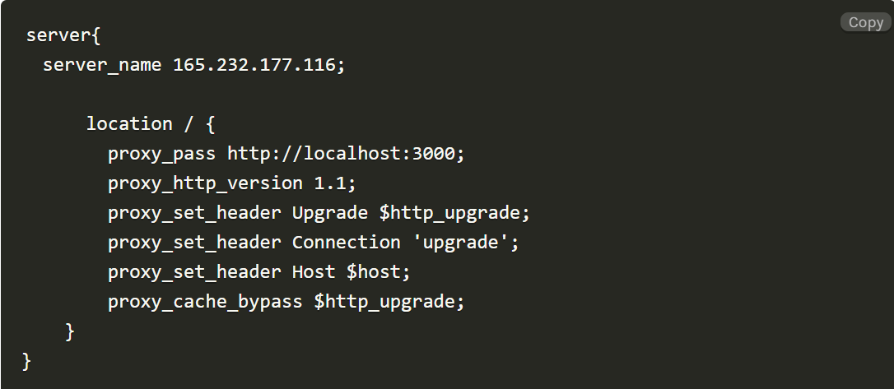
    18. sudo ln -s /etc/nginx/sites-available/nodeApp /etc/nginx/sites-enabled.
    19. cd /etc/nginx/sites-enabled.
    20. sudo rm default.
    21. sudo service nginx restart.
13. Navigate to <http://4.236.142.98> the app is up and running. With mongo db database.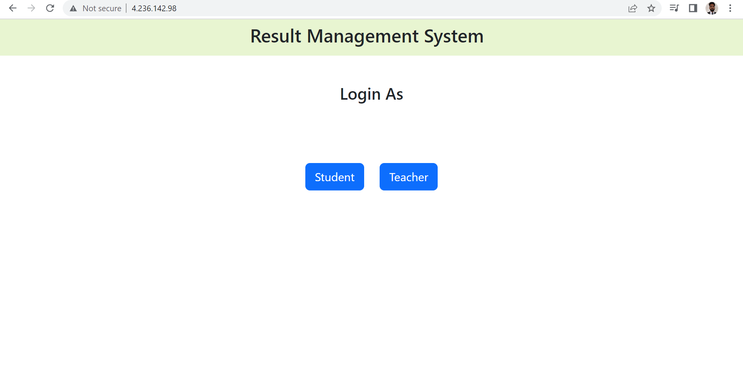

* Deploy the same application to Azure App Service. It should also leverage the database on the cloud.

Steps: -

1. On Azure Search for Azure Cosmos DB. 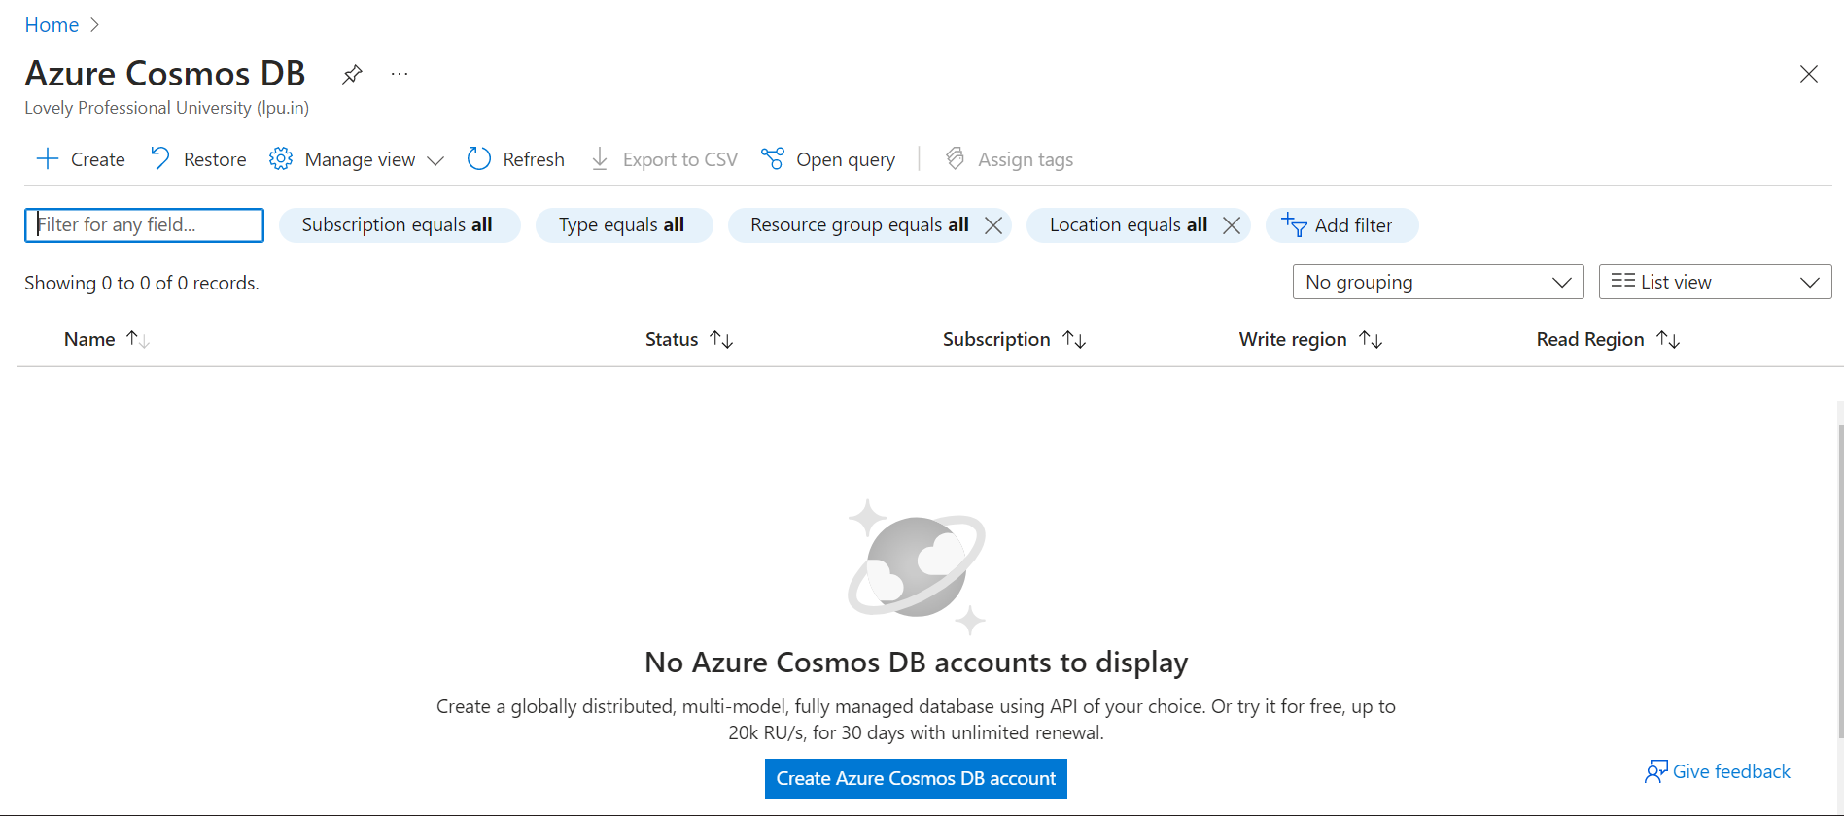
2. Click on Create. Then Click on create of Azure Cosmos DB for MongoDB**.** 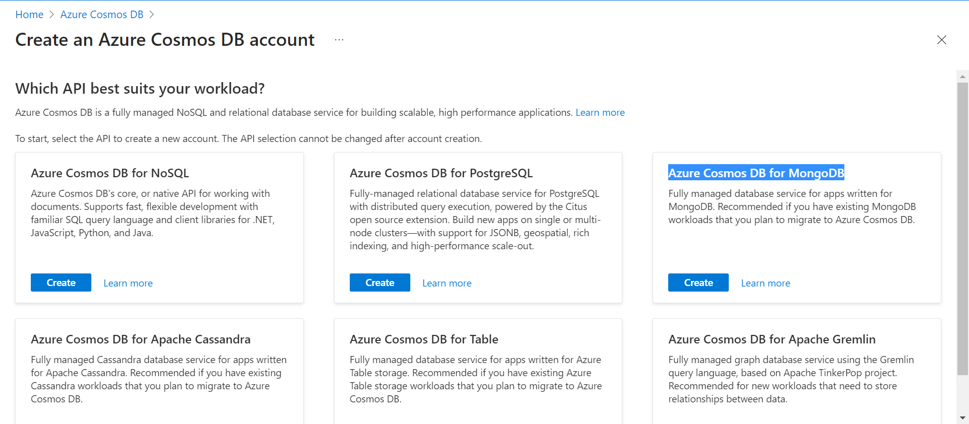
3. Click on Request Unit Create. 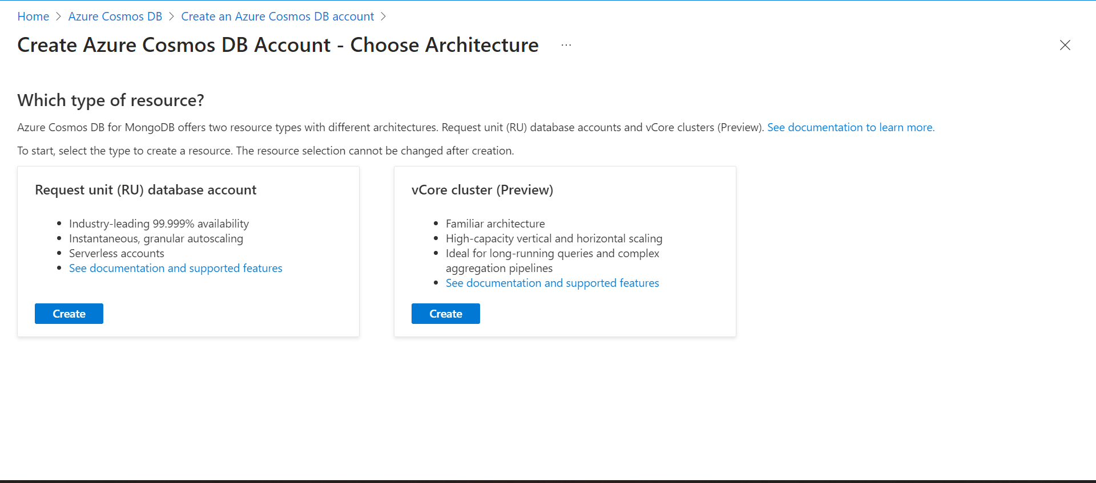
4. Fill the Resource Group and Account Name as shown. Leave the rest as default. 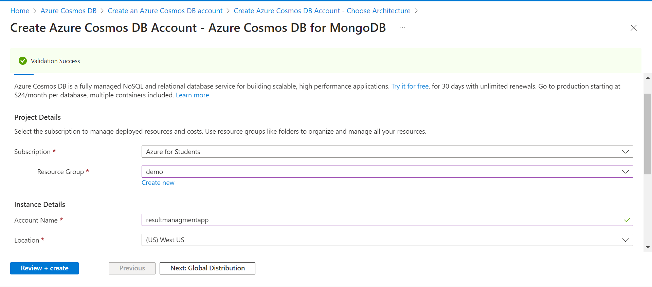
5. Click Review + Create. And the Create. 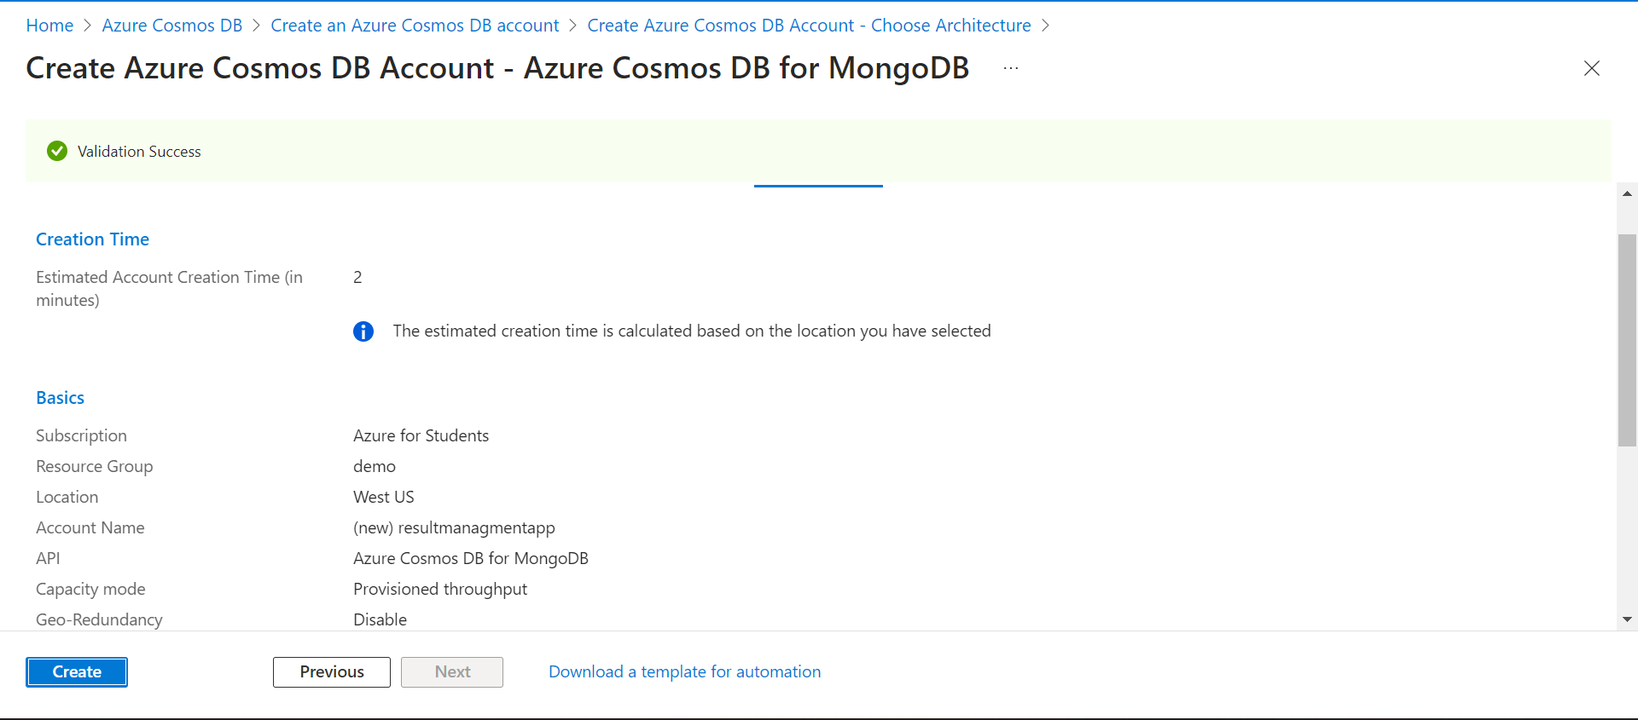
6. Resourse is created. 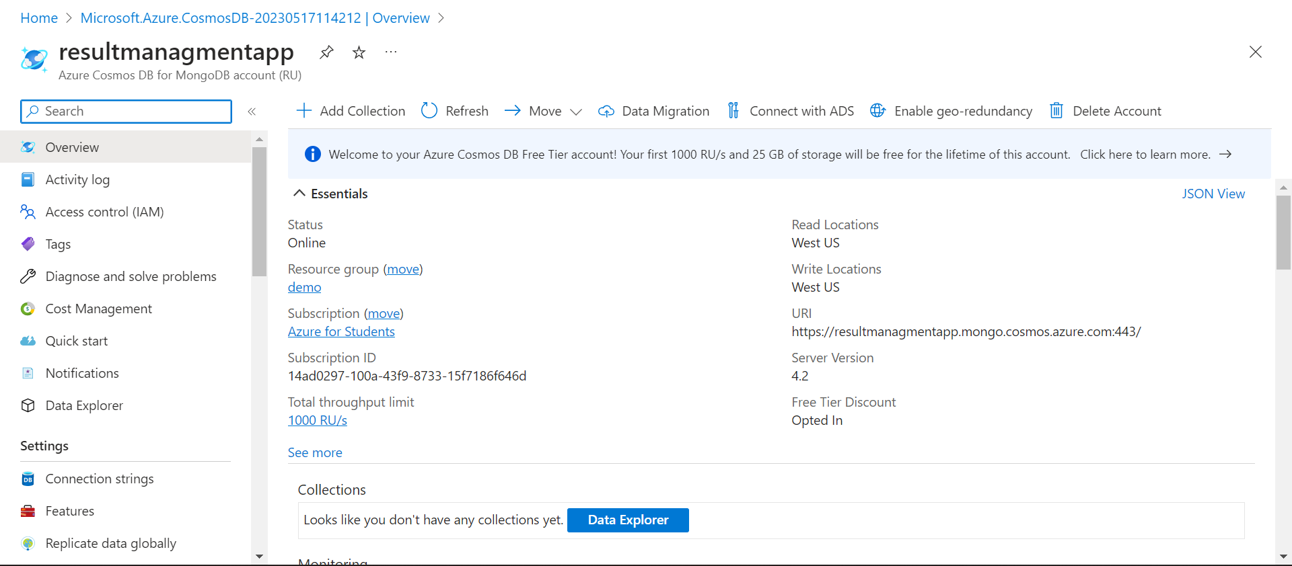
7. Now push your project code on GitHub. 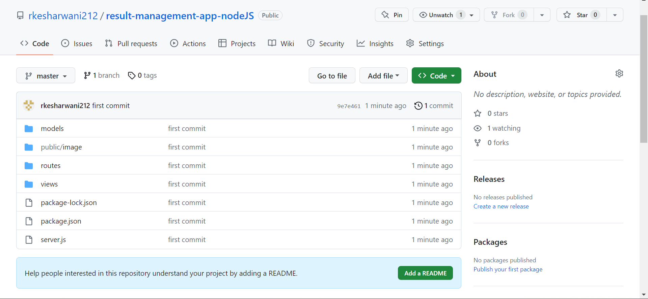
8. Now go to Azure search for App Service. And click on create.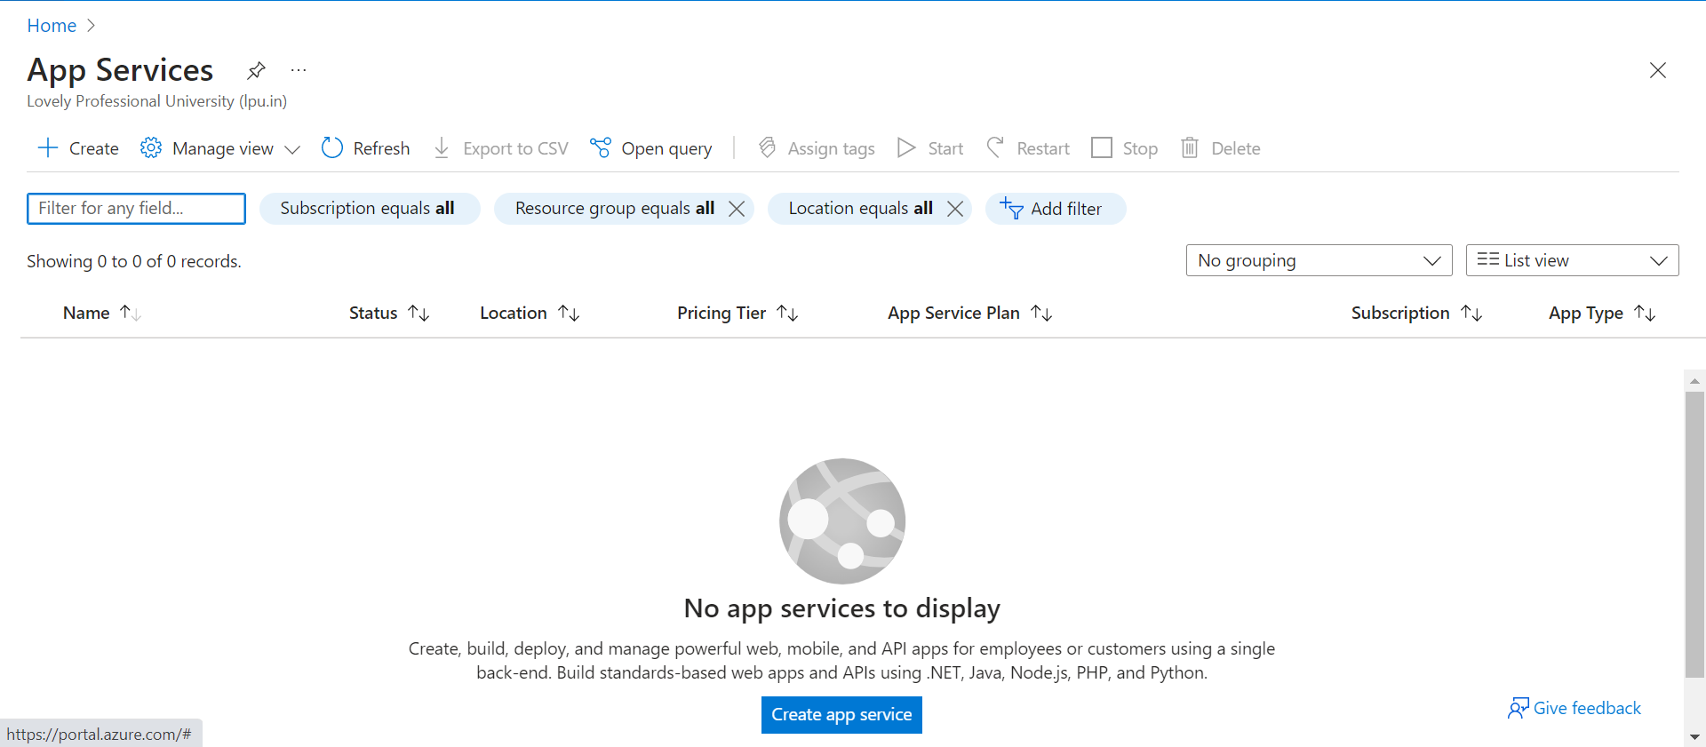
9. Fill resource group, name and runtime stack as show. Leave rest as default. 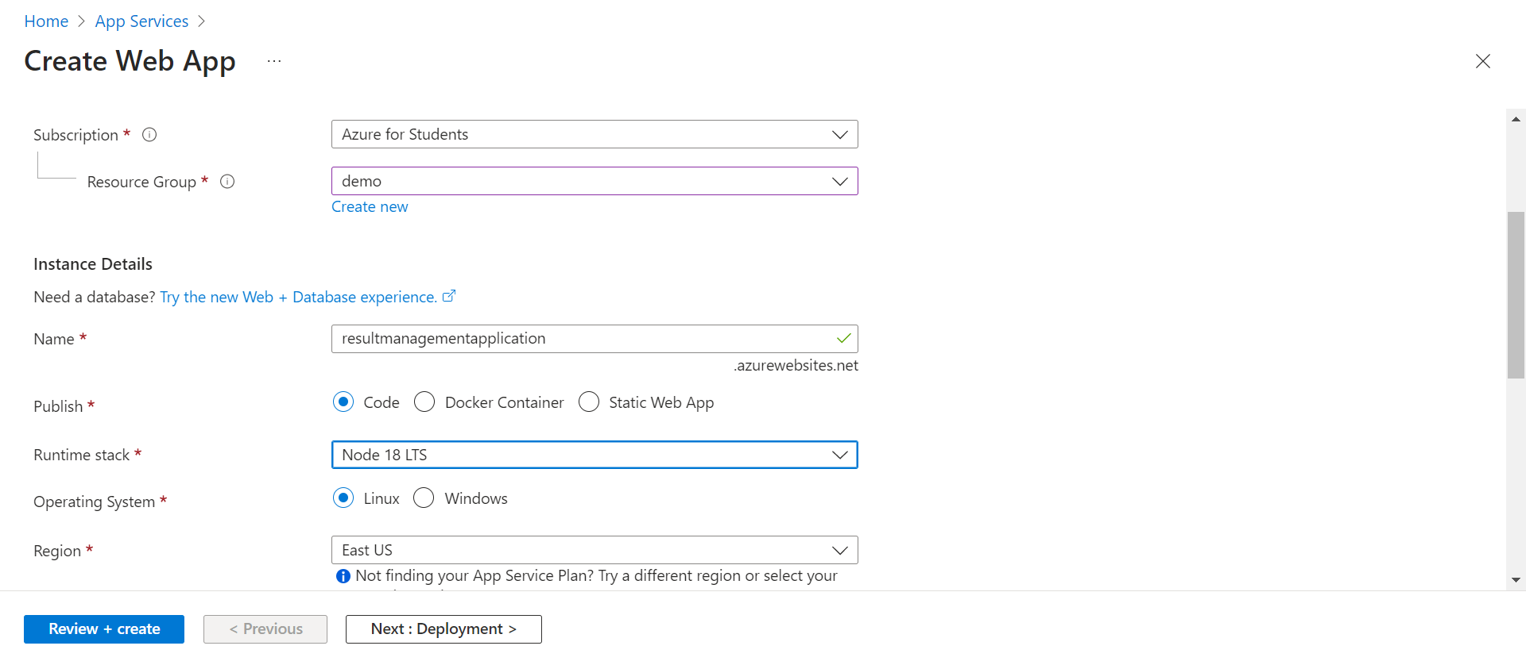
10. Go to Create + Review and click on create. 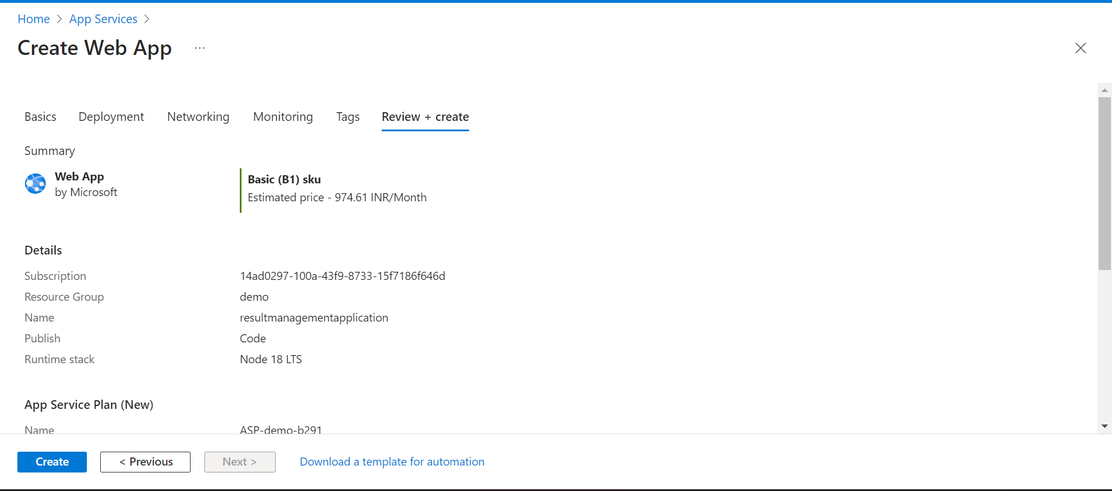
11. App service is created. 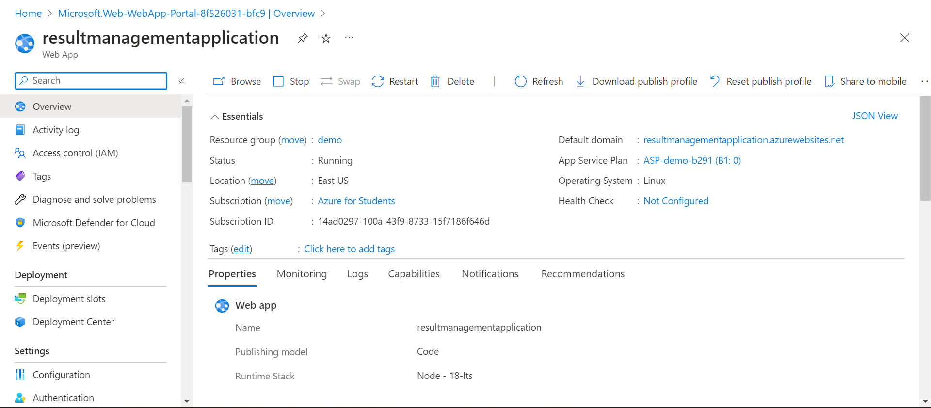
12. Now from resultmanagementapp. Go to Connection String from left pannel. Copy primary connection string. 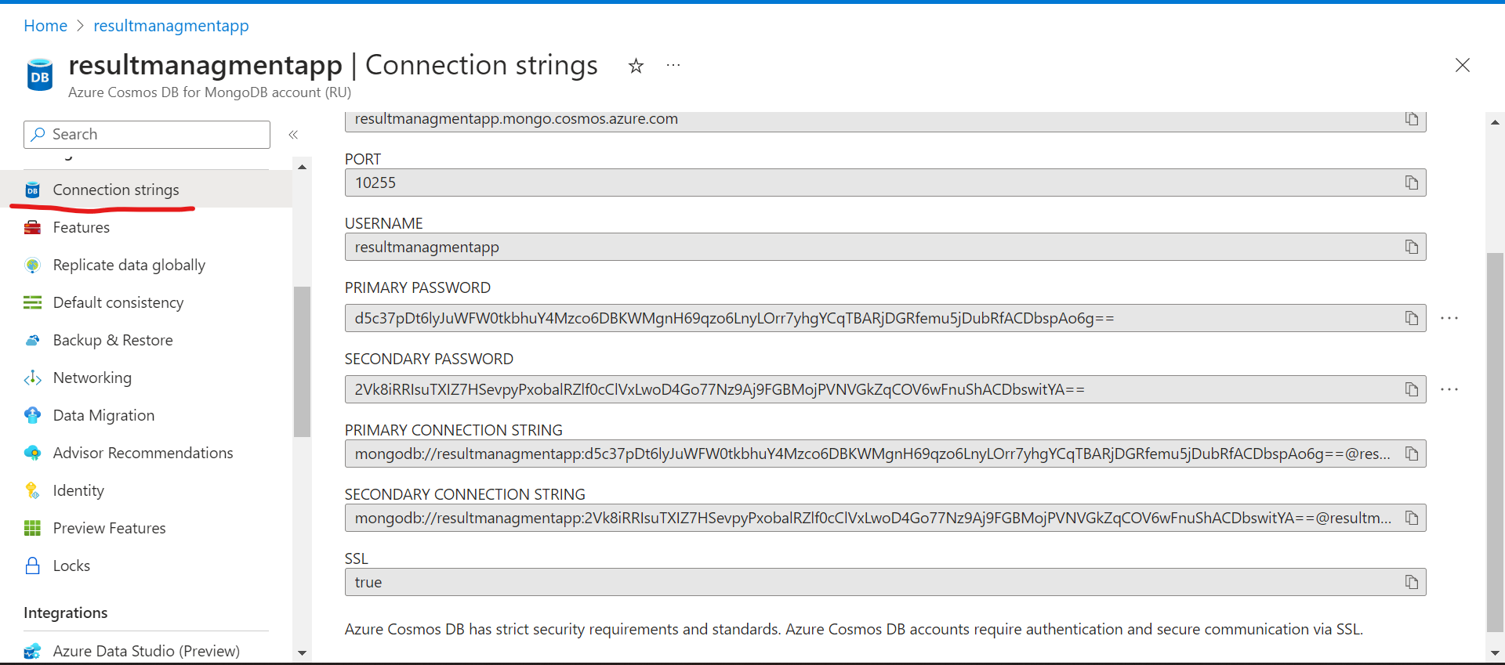
13. Now go to Configuration from left pannel of resultmanagementapplication resource. 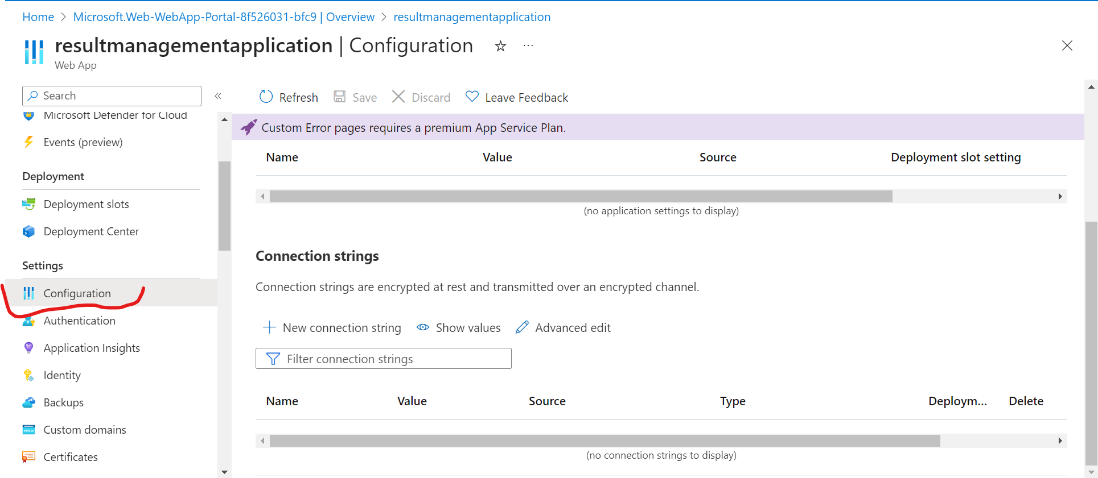
14. Click on + New Connection String. Fill the details as show and click on ok. And then save.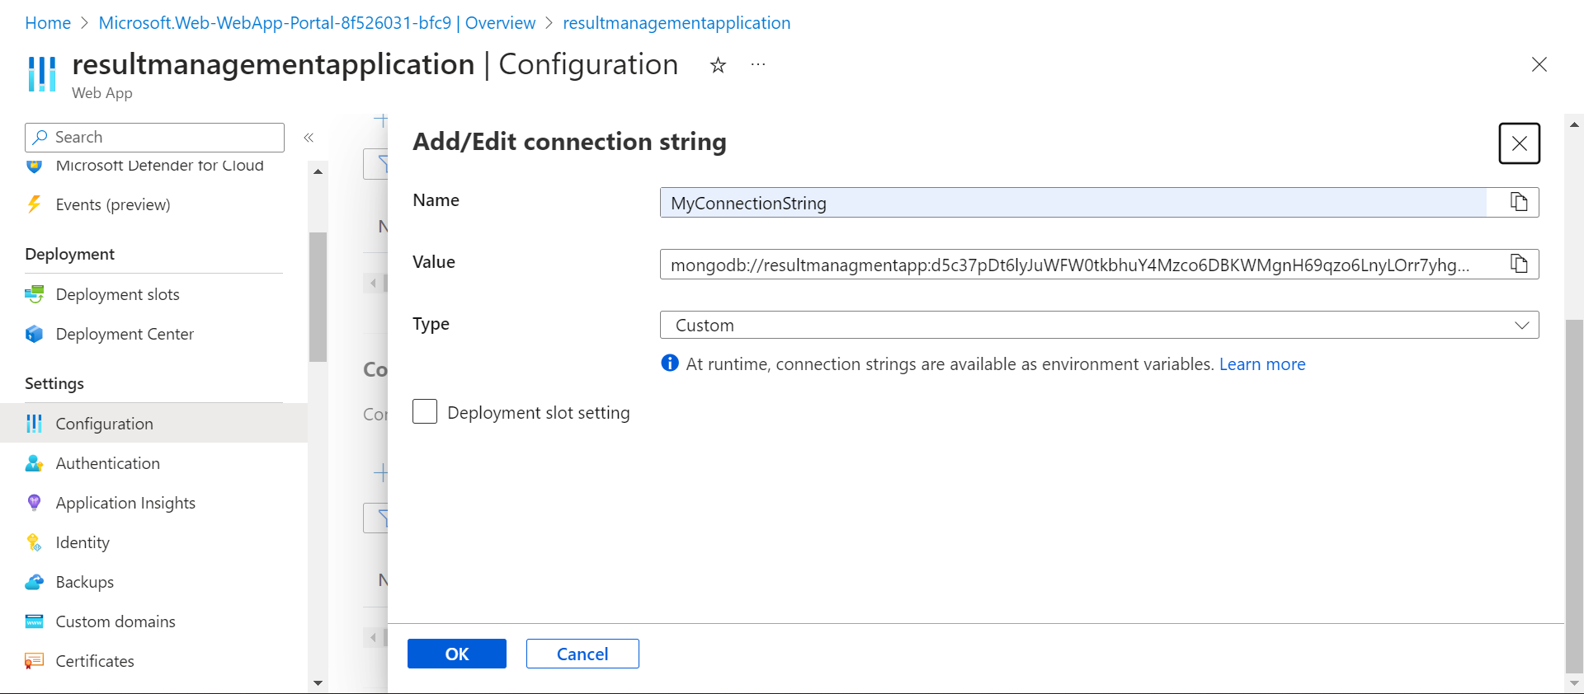
15. New Connection string is added. 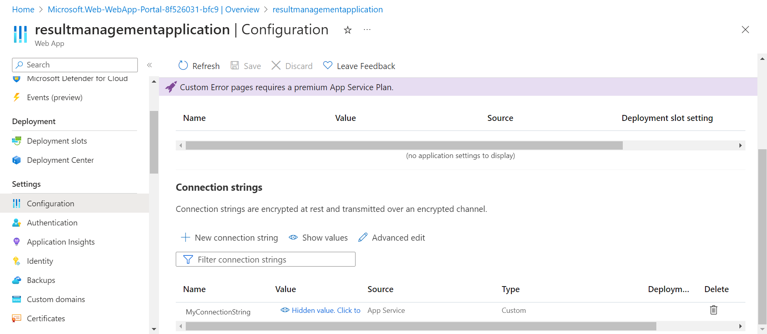
16. Now in the code add the MyConnectionString as shown. Then Push the changes in your git repo. 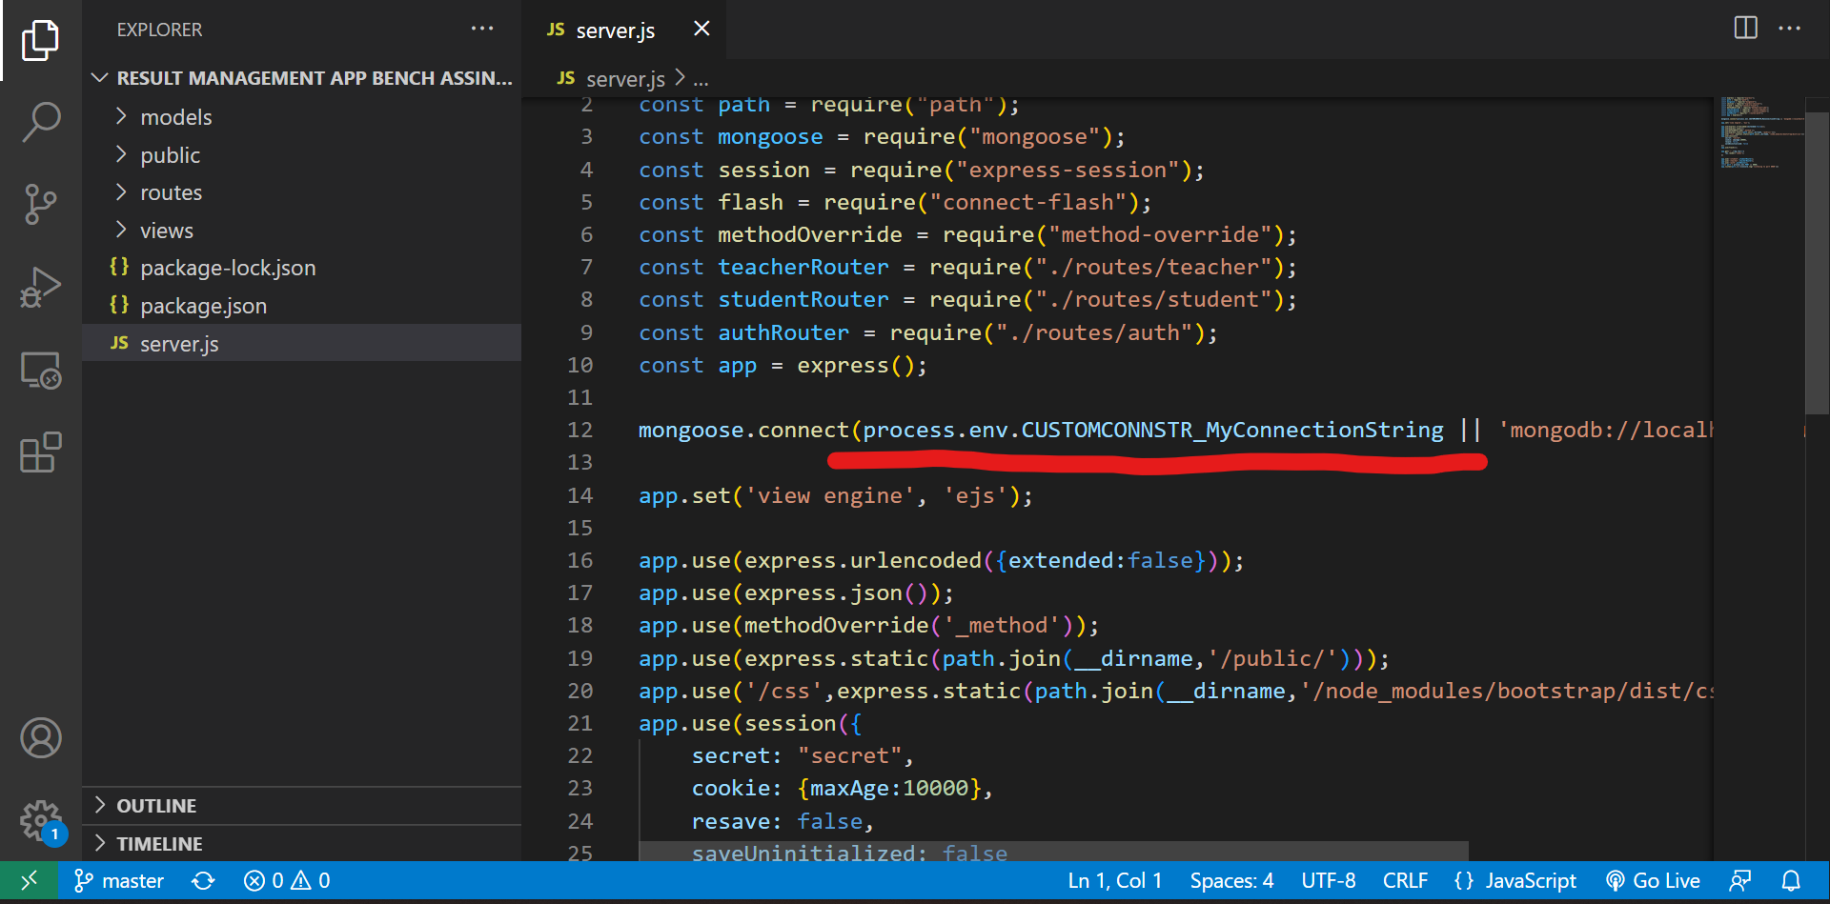
17. Now go to Development Center from left pannel. Choose GitHub in Source. As Shown.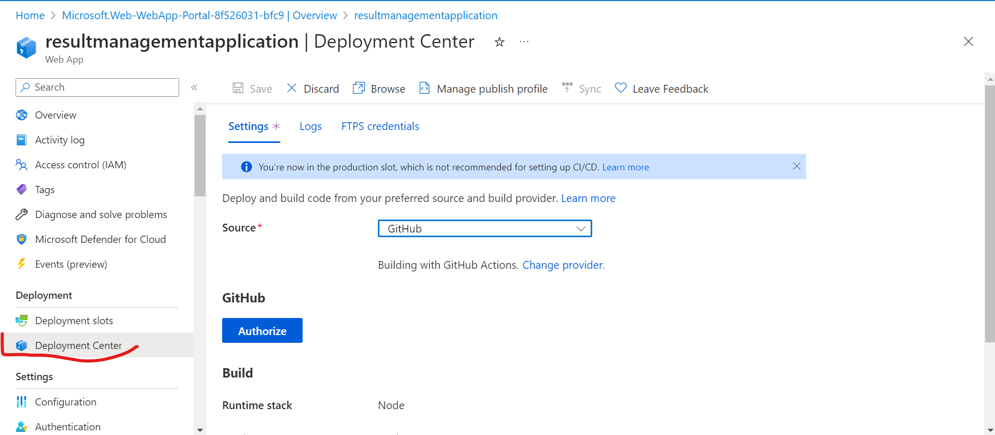
18. Now click on Authoize and login you github creadential.
19. After that choose you repository in which you have pushed your code. And then click on save.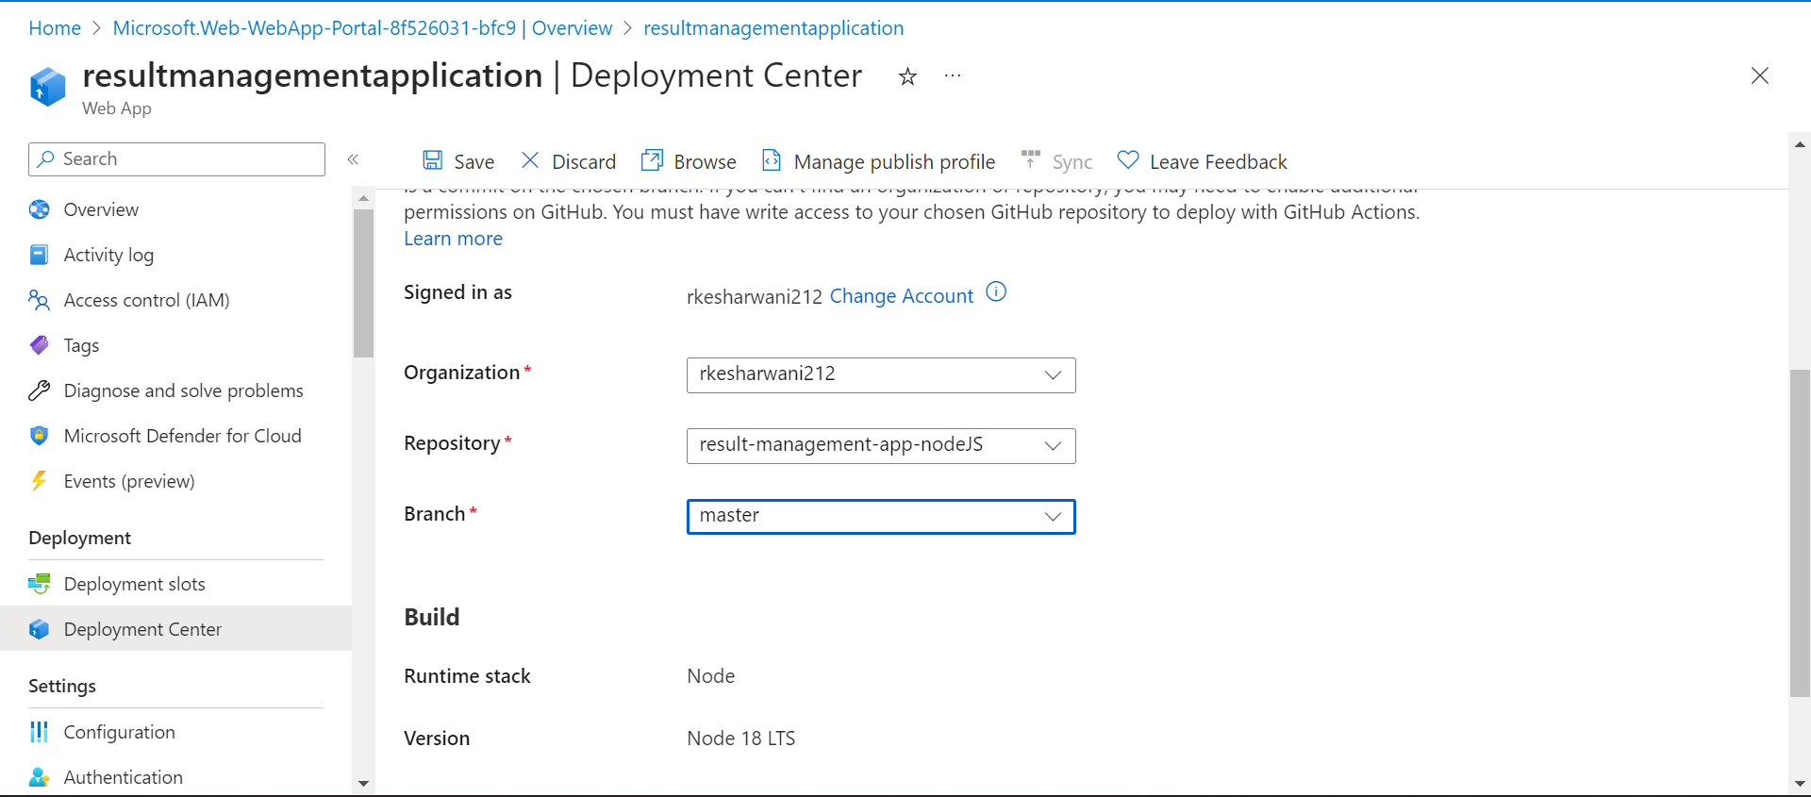
20. Now in overview click on default domain to navigate to you app.

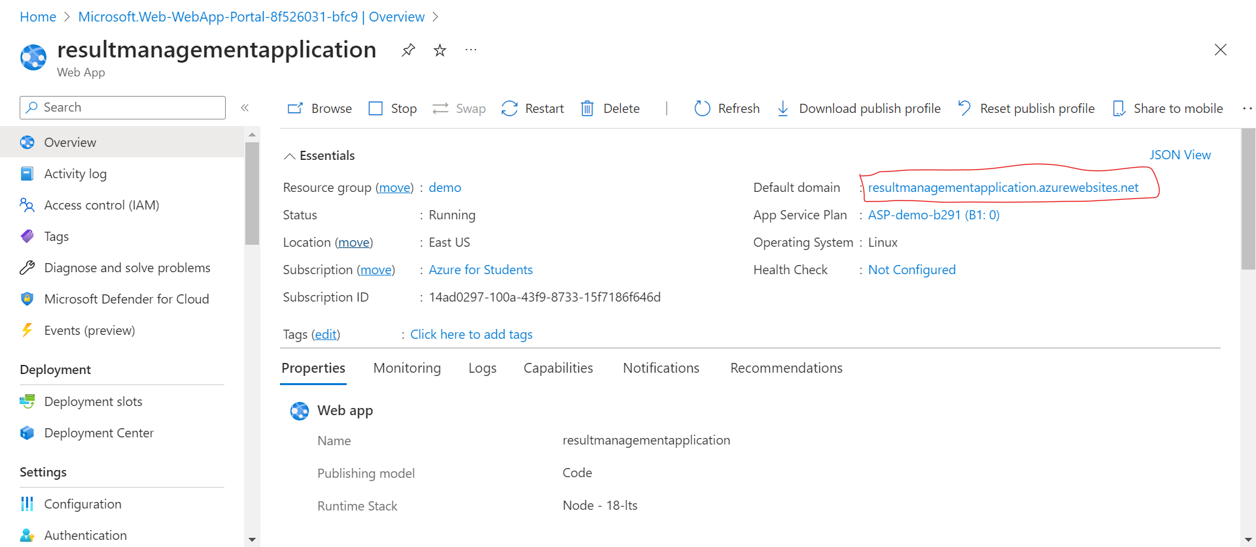

The app is up and running. 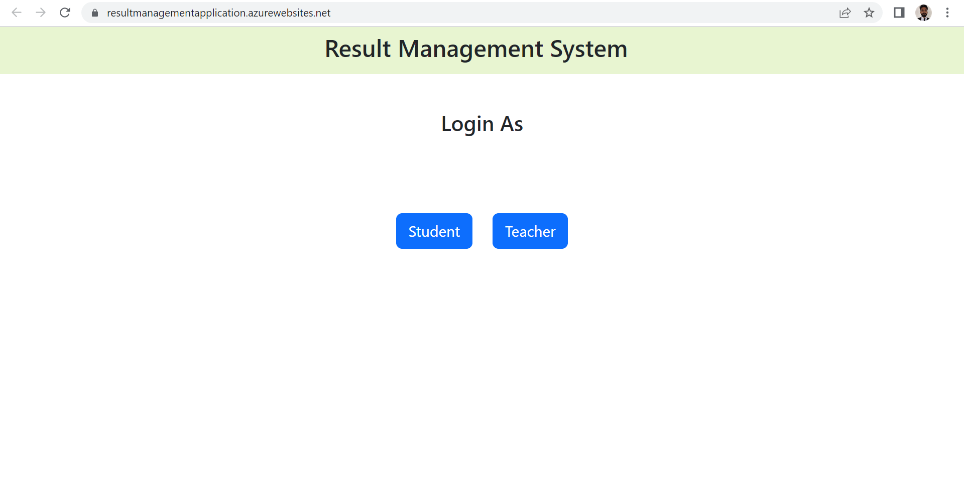

* Create the AKS cluster (2 nodes, smallest size VM) and deploy any two services on it. Services should be accessible from the internet.

1. Go to your Azure Search for Kubernetives services. Click on create. Fill the information as shown. 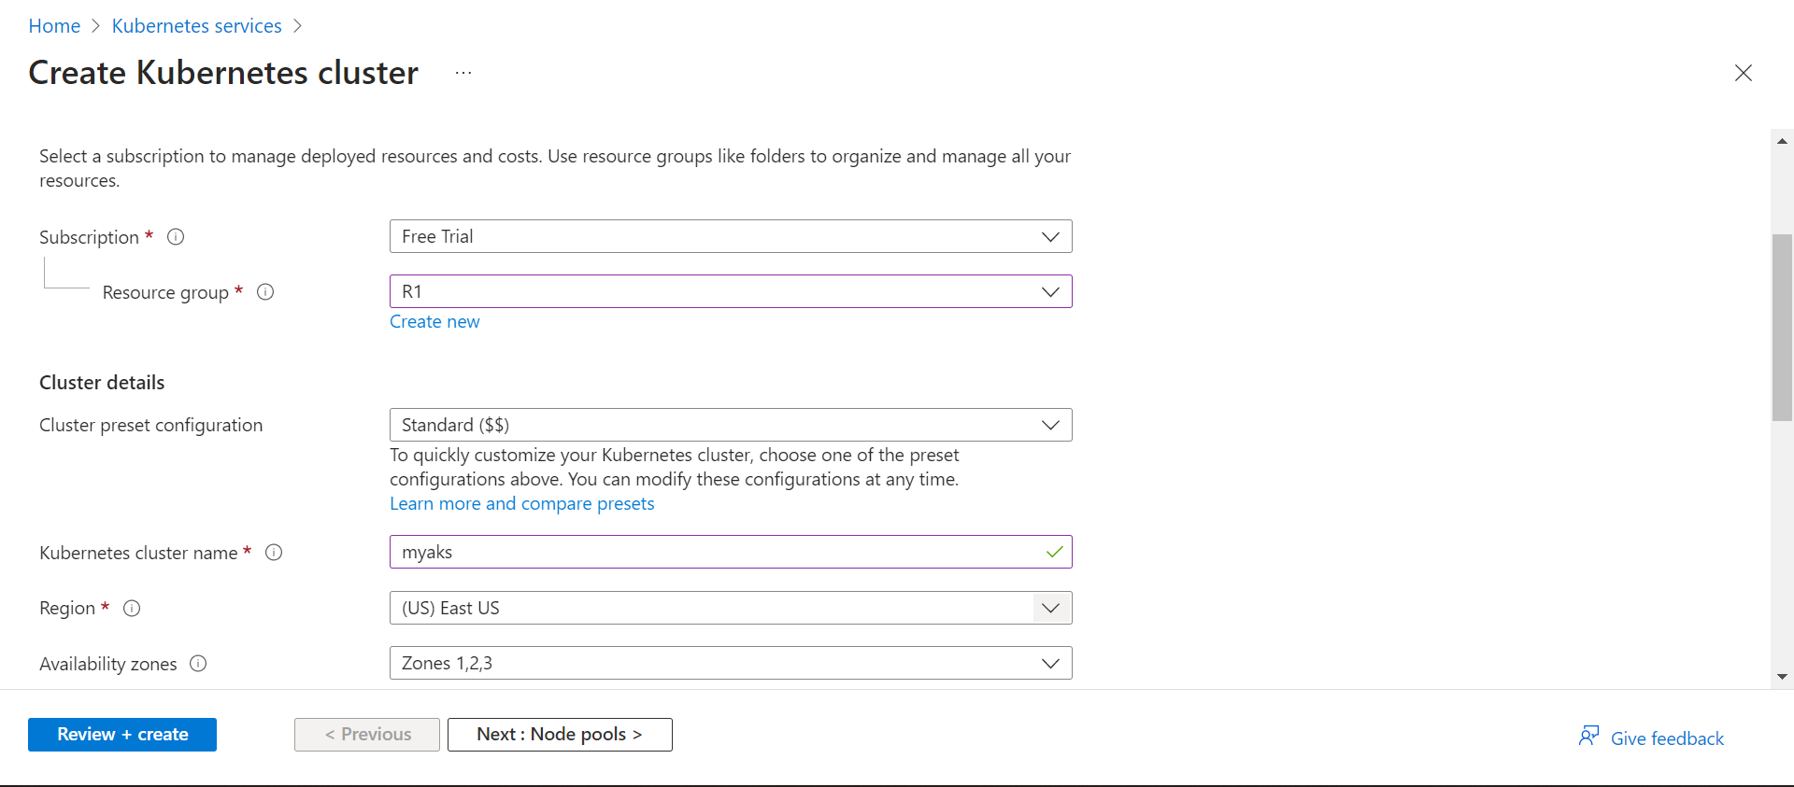
2. In scale method choose Manual and write 2 in the node count. As shown. 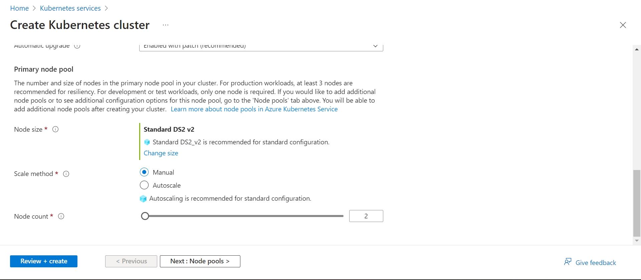
3. Now leave the rest as default and click on review + create. After valiadation click on create. 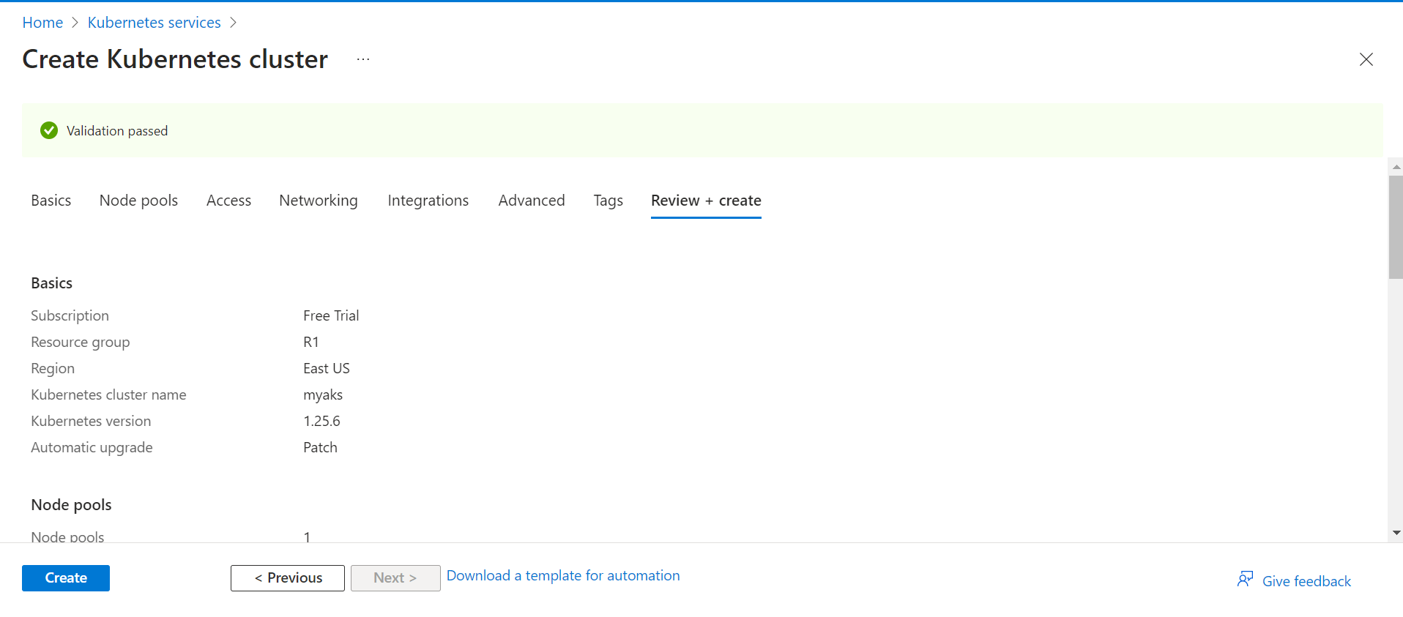
4. Kubernetes cluster is created. 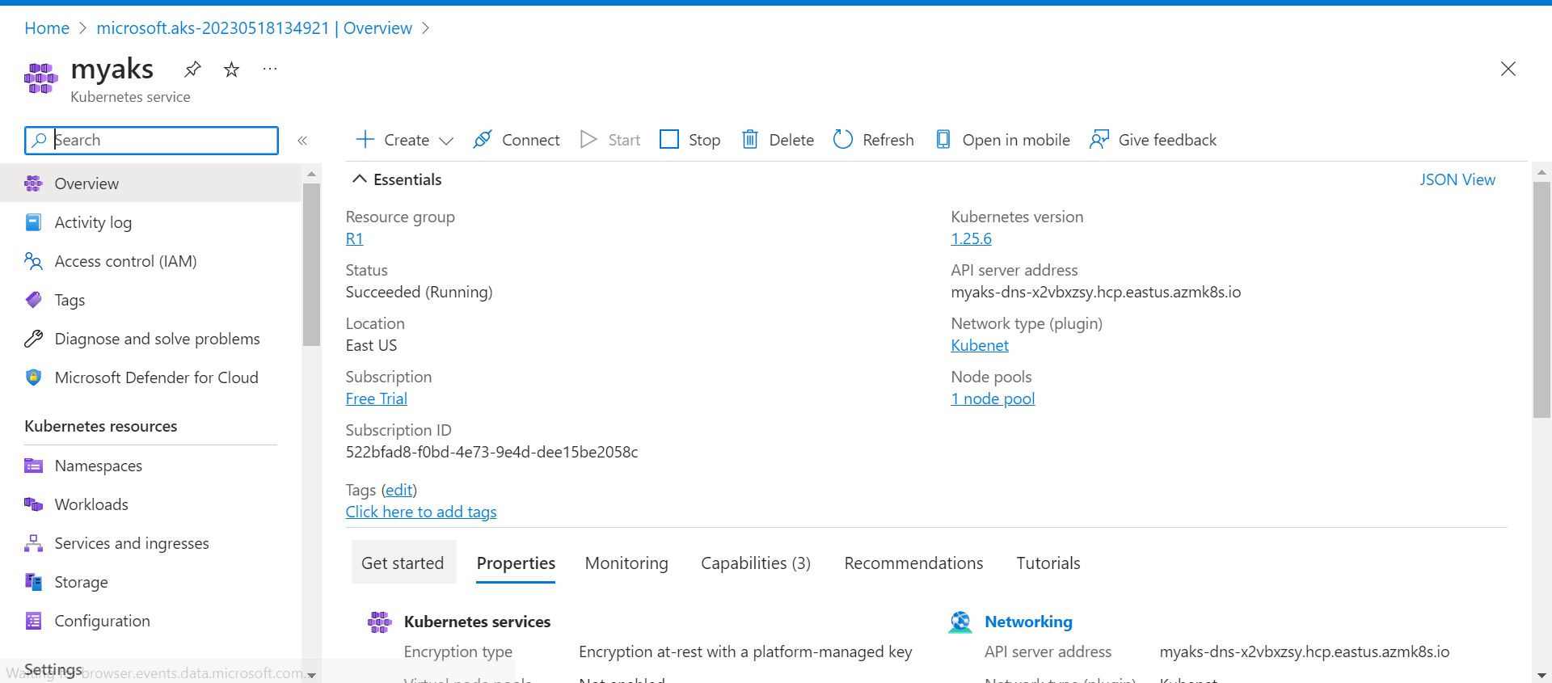
5. Now got to cloud bash run the following command.
   1. az account set --subscription 522bfad8-f0bd-4e73-9e4d-dee15be2058c
   2. az aks get-credentials --resource-group R1 --name myaks
   3. code azure-vote.yaml
   4. paste your yaml.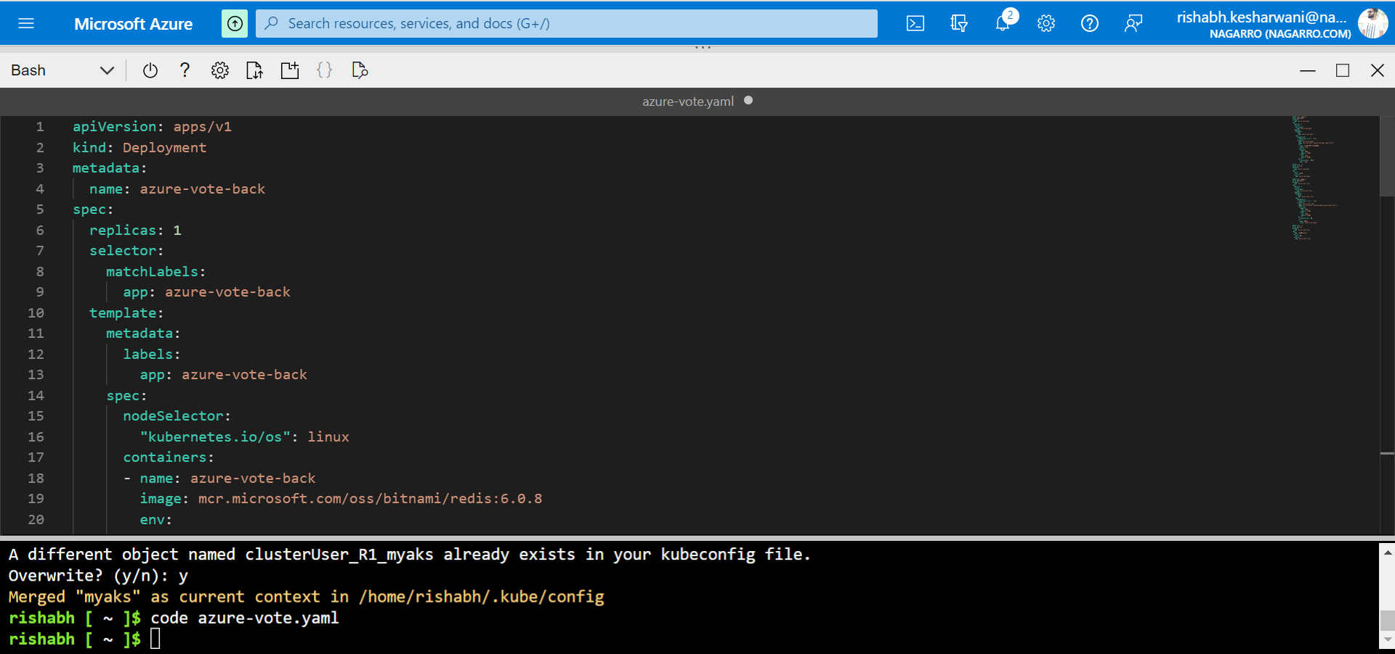
   5. kubectl apply -f azure-vote.yaml
   6. kubectl get service.
6. Service has deployed now. 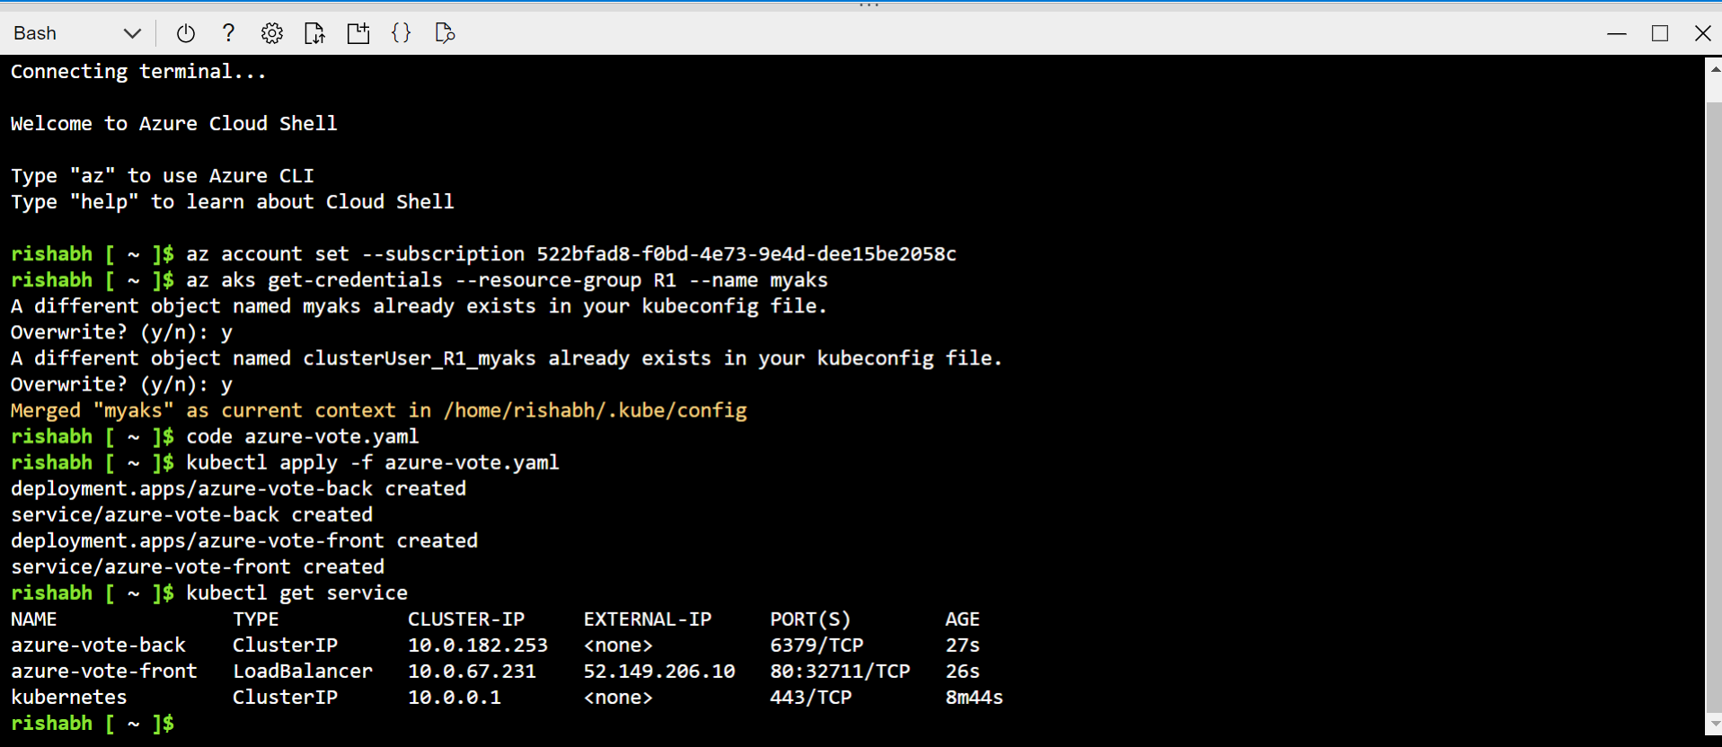
7. Navigating to the ip to check app is up and running. 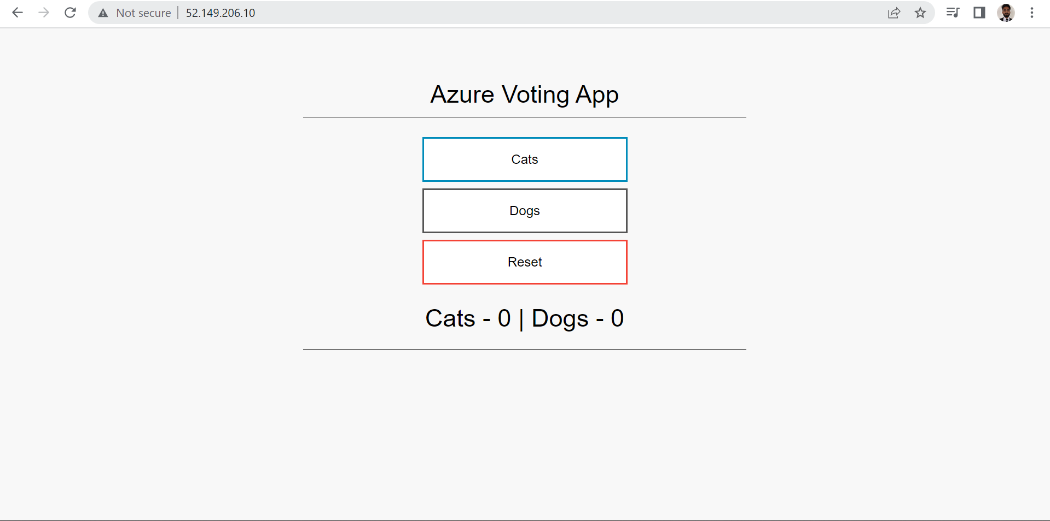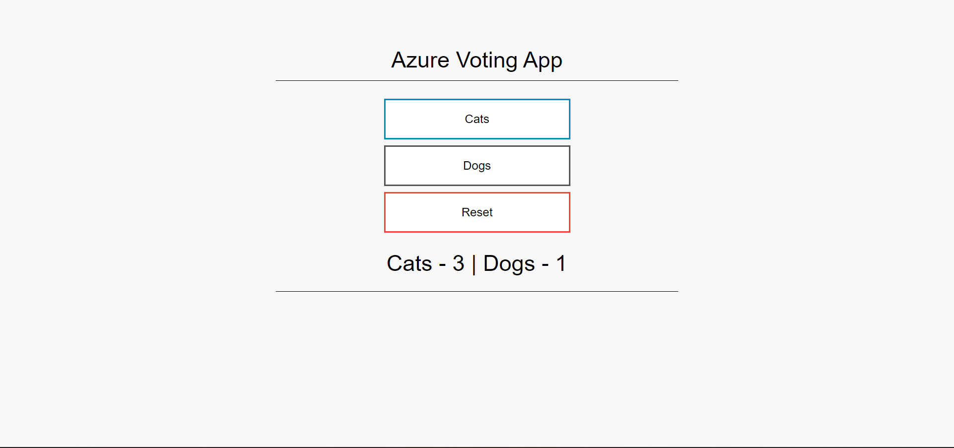
8. The app is running with two services backend and front end.

* Create an Azure function that should trigger as soon as you upload a file in the blob storage. Function should be able to print the name of the file uploaded in the function.

1. Go to azure search azure function app click on create. Fill the info as show.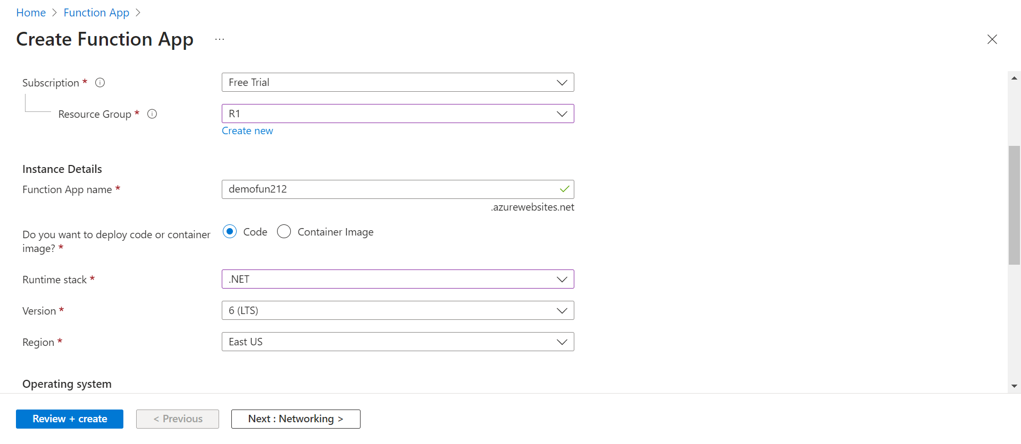
2. Click on create + review. 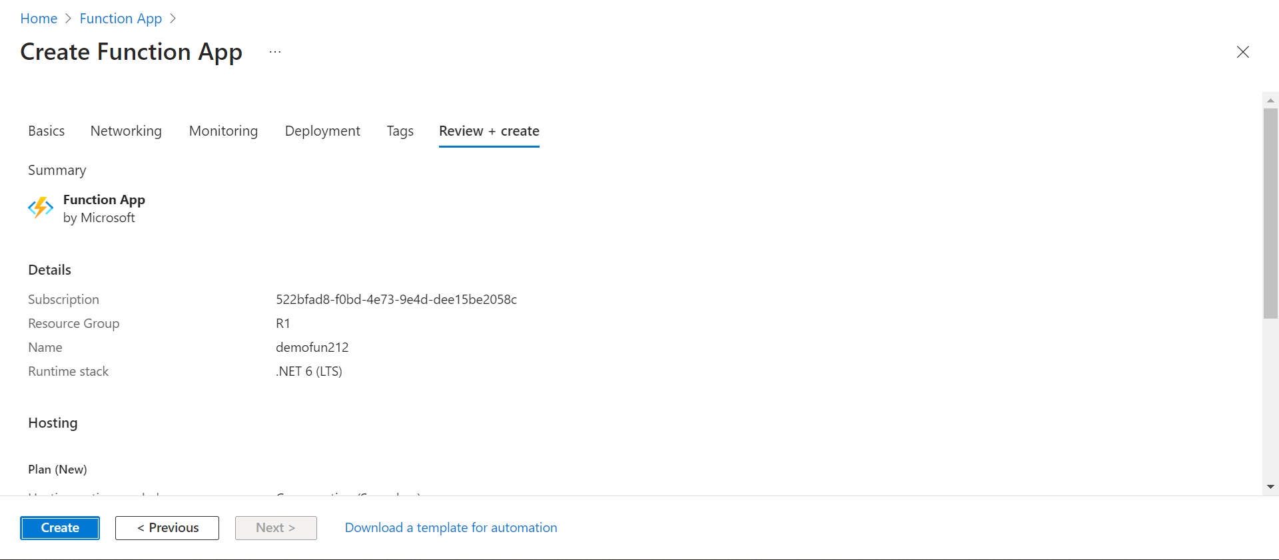
3. Click on create. Resourse is created.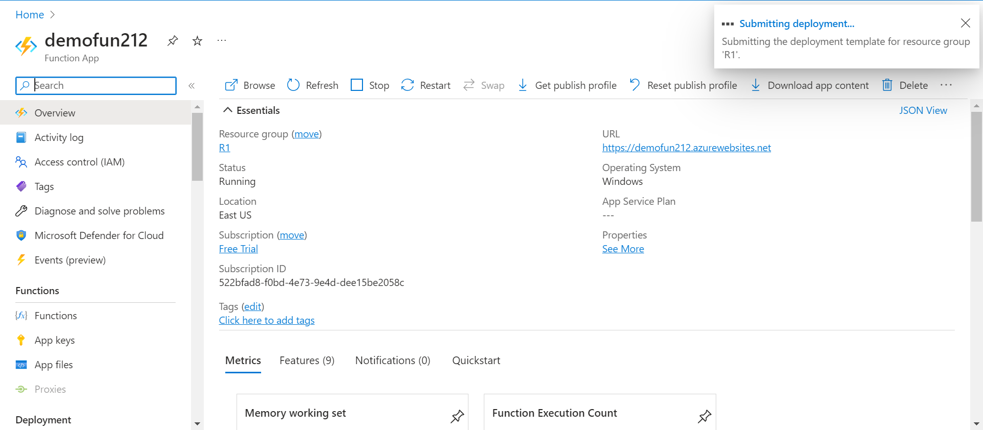
4. Search for storage account and click on create. 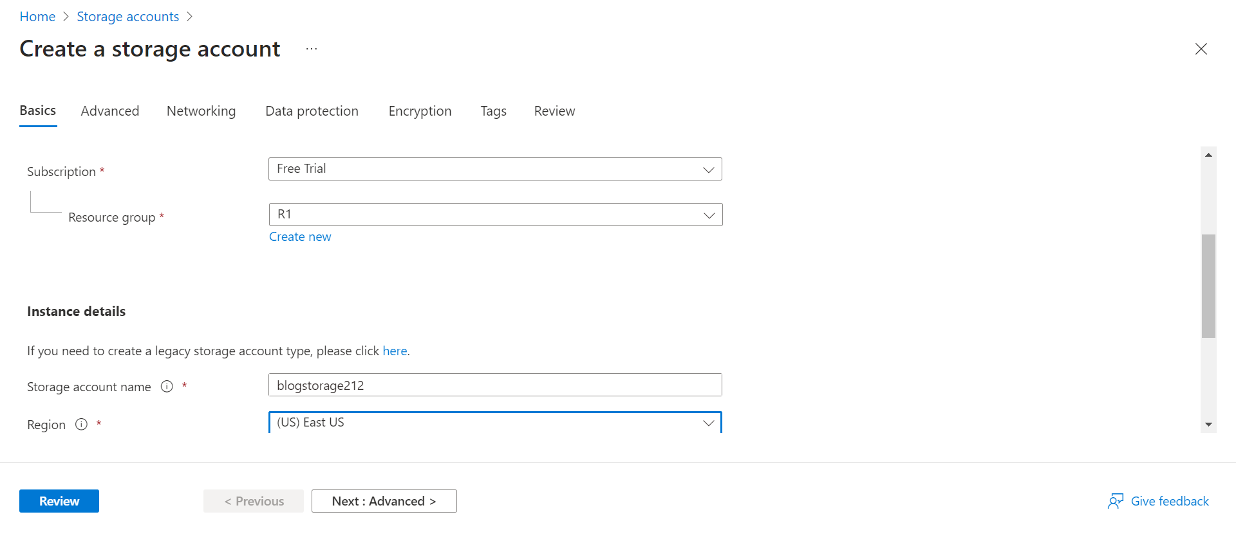
5. Click on review. 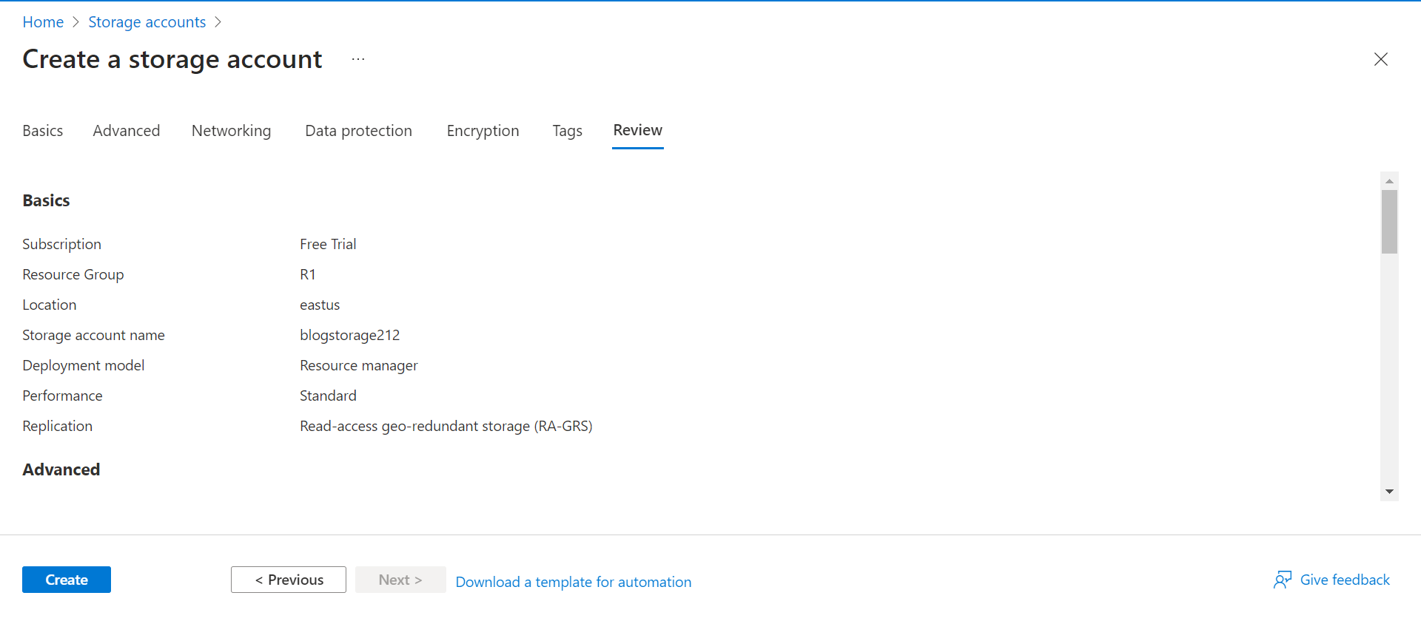
6. Now click on create. Resource is created.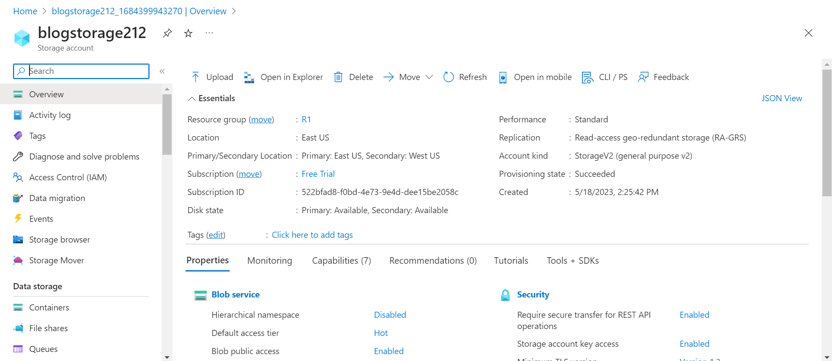
7. Now go to demofun212 resourse and click on functions. 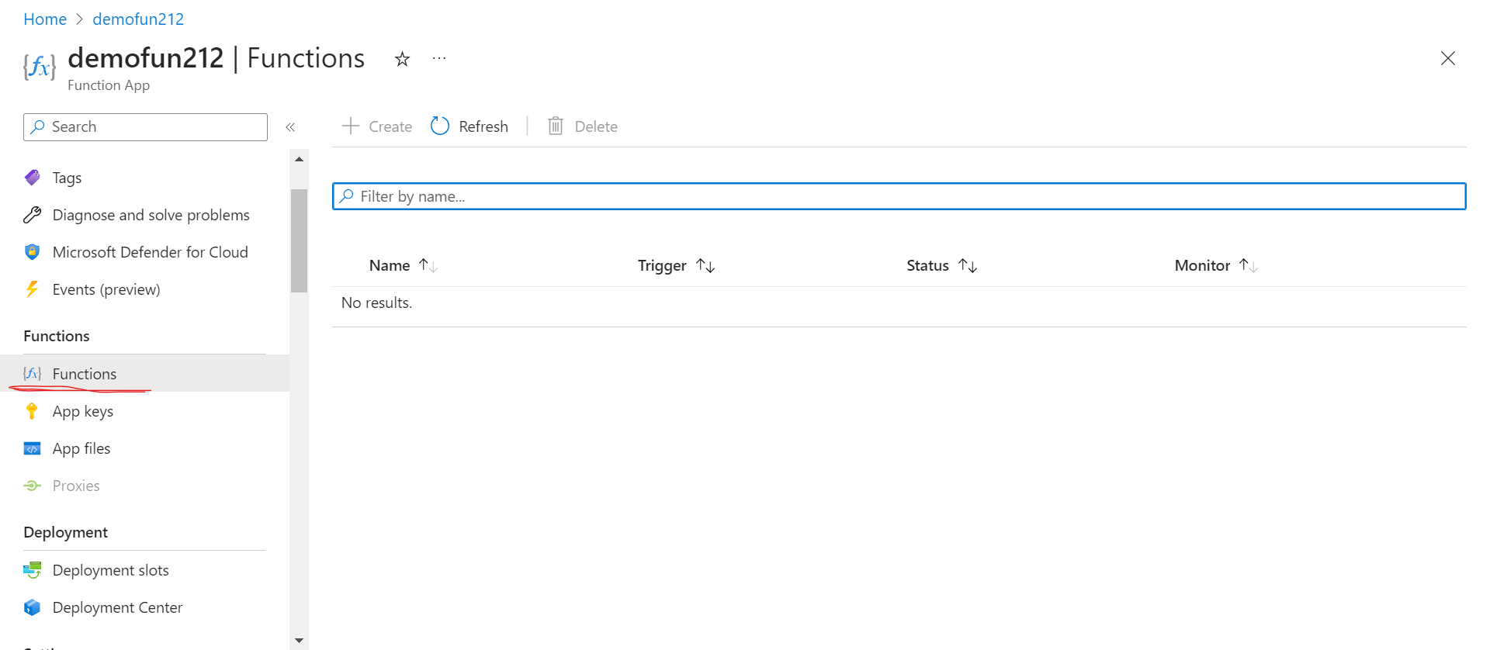
8. Create a blob storage trigger. 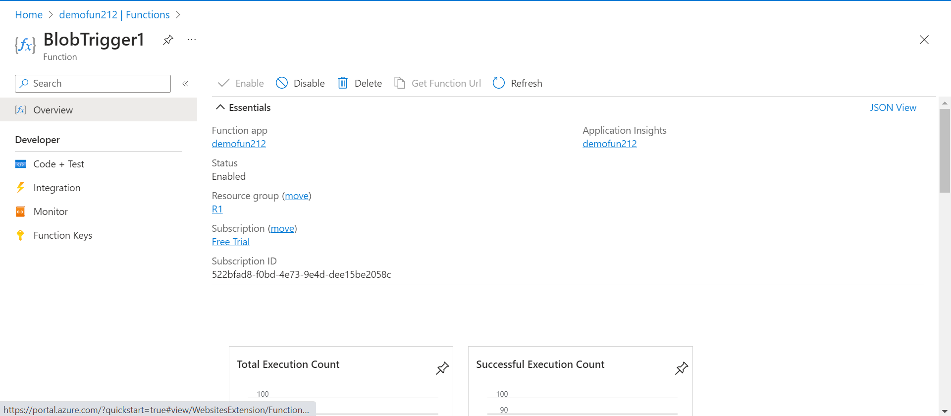
9. Go to code+test. Write the function as show.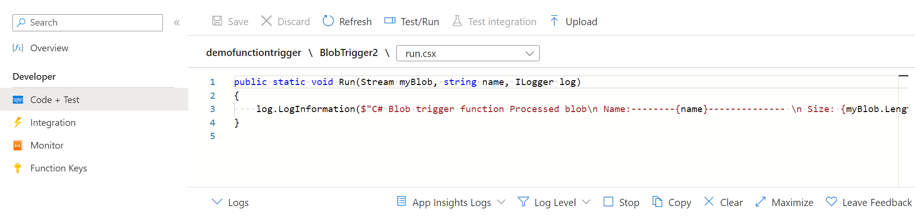
10. Now in blogstorage212 resource go to containter. 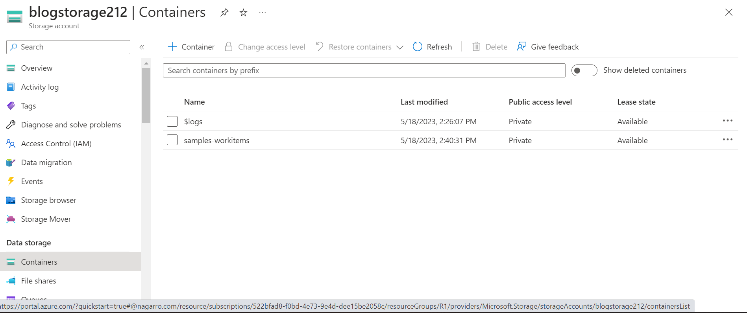
11. Click on +container and create a container named sample-workitems.
12. Upload a file in that. 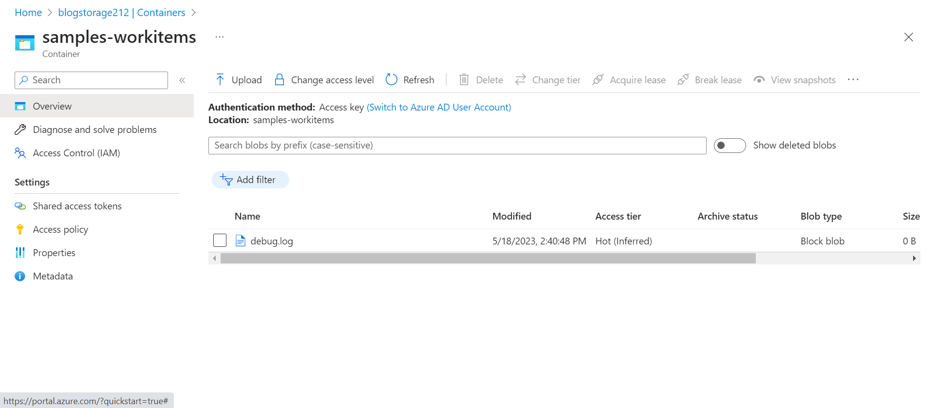
13. Now go to demofun212 resource in function click the function created above and the go to code+test.
14. See the logs name of file i.e. debug is printed. 